**Major Project Report On**

**Online Healthcare Website**

*Submitted in partial fulfilment of the degree of Master of Computer Application (MCA)*

*By:*

|  |  |
| --- | --- |
| **NAME** | **ROLL NO.** |
| SOHELY MAITRA | **18771021003** |
| SOMDUTTA BISWAS | **18771021032** |
| SOMTIRTHA PAUL | **18771021055** |
| SK ASHADUL HOSSAIN | **18771021063** |

*From: Techno International New Town*



***Under the supervision of Professor*** ***Hemanta Dey***

***Techno International New Town***

**FACULTY OF MCA DEPARTMENT**

This is to certify that we have completed this project work titled ‘Online Healthcare Website’, under the direct supervision and guidance of Mr. Hemanta Dey. We are grateful for his constant support and guidance due to which this project being presented for the partial fulfillment of the degree of Master of Computer Application (MCA) from Techno International New Town, affiliated to Maulana Abul Kalam Azad University of Technology(MAKAUT).

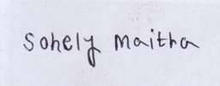

Sohely Maitra

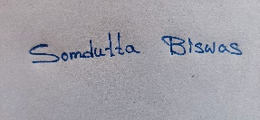

Somdutta Biswas



Sk Ashadul Hossain

Somtirtha Paul

Mr. Hemanta Dey ,

Mentor.



**TECHNO INTERNARIONAL NEW TOWN**

*Affiliated to*

**Maulana Abul Kalam Azad University of Technology(MAKAUT)**

*Certificate of Approval*

The foregoing Major Project is hereby approved as a creditable study of Master of Computer Application (MCA) and presented in a manner satisfactory to warrantits acceptance as a pre-requisite to the degree for which it has been submitted. It’s understood that by this approval the undersigned do not necessarily endorse or any statement made, opinion expressed or conclusion there in but approve this Major Project only for the purpose for which it is submitted.

Signature of Examiners

# PREFACE

Goal of the Major Project:

Online Healthcare Website, titled **“easy Health**”, is a web-based project

developed in PHP. The purpose of the project is to simplify the appointment booking process for the users. By the use of Online Healthcare Website customers can easily book their appointment, and Doctors can take appointments.

We are pleased to present a comprehensive documentation also describing our learning through this great project.

# ACKNOWLEDGEMENT

#### It has been a matter of immense pleasure, honor and challenge to have this opportunity to take up this project and complete it successfully,

We would like to express our profound gratitude to the faculty of Master of Computer Application, for their continuous guidance, valuable suggestions and constant moral support, encouragement and advices throughout the period of the progress in this project. We are grateful to them for providing us all the help and necessary resources. We also convey our thanks to our teachers of respecting department for providing us all needed support and laboratory, as and when required.

#### Lastly, we would also like to thanks all the people who had been a constant source of motivation for us.

**TABLE OF CONTENTS**

Chapter 1: Introduction

* 1. : Introduction Page 7
  2. : Scope of the project Page 7

Chapter 2: Functional Requirements

* 1. : Hardware requirements Page 8
  2. : System requirements Page 8

Chapter 3: Project Analysis

* 1. : Cost Analysis (Using basic COCOMO model) Page 9
  2. : ERD Page 10
  3. : Data Flow Diagram Page 11-12

Chapter 4: Page Design Page 13

Chapter 5: Source Code Page 28-77

Chapter 6:Future Scope Page 78

Chapter 7: Conclusion Page 78

Chapter 8: References Page 79

**Chapter 1: Introduction**

* 1. **Introduction**

Easy Health is a Website created for medical use, we built it using PHP,Mysql,Html,CSS. This application has the following features included such as:-

* + - Patients can book their appointments.
    - Doctor can create their profile.
    - Patients can check their previous appointment history.
    - Patients can check their previous medical history.
    - Doctor can prescribe using the website.
    - Patients can check previous prescription.
    - To improve the overall healthcare experience for users

## Scope of the project

This online healthcare website has the objective to create a user friendly appointment booking website and maintain the privacy of the users. To automate and optimize various healthcare management tasks, such as appointment scheduling, patient registration, medical records management, and inventory management. It will help to reduce the workload of healthcare providers and increase their efficiency, comply with regulatory requirements and ensure data privacy and security.To provide analytics and reporting features that can help healthcare providers to track their performance and make informed decisions.

## Chapter 2: Functional Requirements

|  |
| --- |
| **2.1. SOFTWARE REQUIREMENTS:** |
|  |
| Windows Any |
| XAMPP |
| VS Code |
|  |

|  |
| --- |
| **2.2. HARDWARE REQUIREMENTS**: |
|  |
| Processor :Intel Pentium to any updated |
| Processor Speed : 250MHz to 667 MHz |
| RAM : Minimum 2GB |
| Hard Disk : 80 GB |
|  |

## Chapter 3: Project Analysis 3.1_Cost Analysis using COCOMO model

We are using a basic cocomo model based on LOC, i.e. number of lines of code. It is a procedural cost estimate model for software projects. Please refer to the data given below to verify the proceedings.

|  |  |  |
| --- | --- | --- |
| SOFTWARE PROJECTS | A | B |
| Organic | 2.4 | 1.05 |
| Semi Detached | 3.0 | 1.12 |
| Embedded | 3.6 | 1.20 |

Please refer to the equations below to verify the analysis.

* + 1. Effort Applied = a(KLOC)b [ man-months ]
    2. Development Time = c(Effort Applied)d [months]

**Our project consisting of 1.82 KLOC falls under the category of organic mode.**

1. **Effort (E) = a* (KLOC) /\b**

= 2.4 * (1.82) /\1.05

= 4.5007

= 4 person- months

### Tdev = C * (E) ^ d

= 2.5 * (4) /\0.38

= 4.2337

= 4 months

**3.3 Entity Relationship Diagram:**

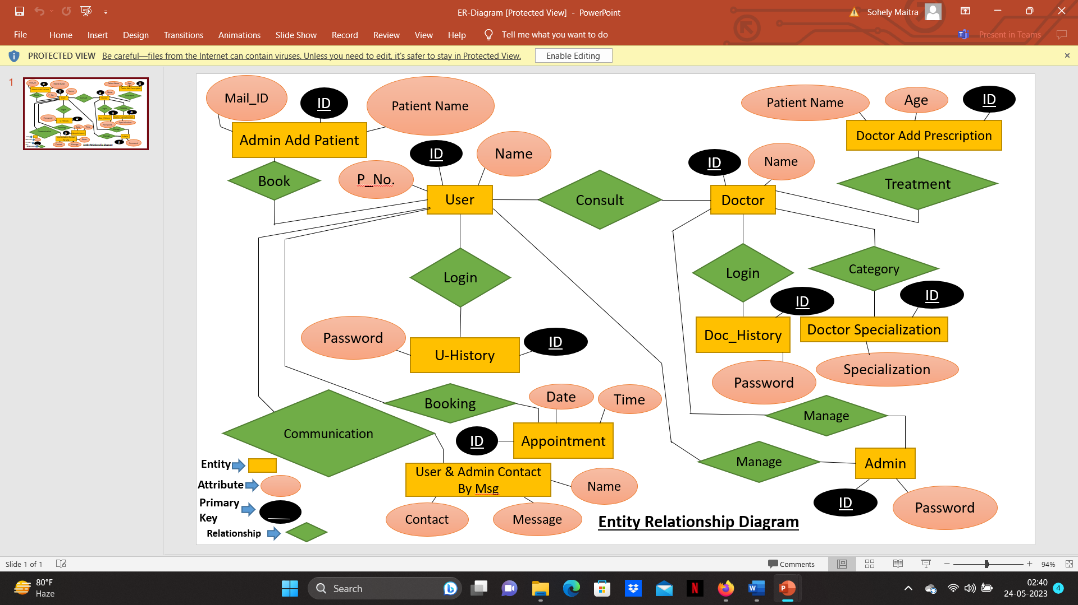

## _Data Flow Diagram:

* + 1. **Level 0 DFD/Context Diagram**

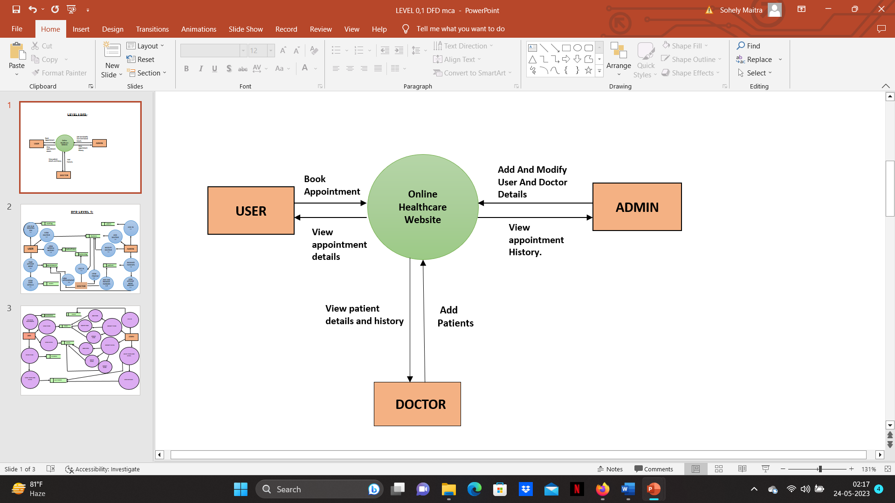

* + 1. 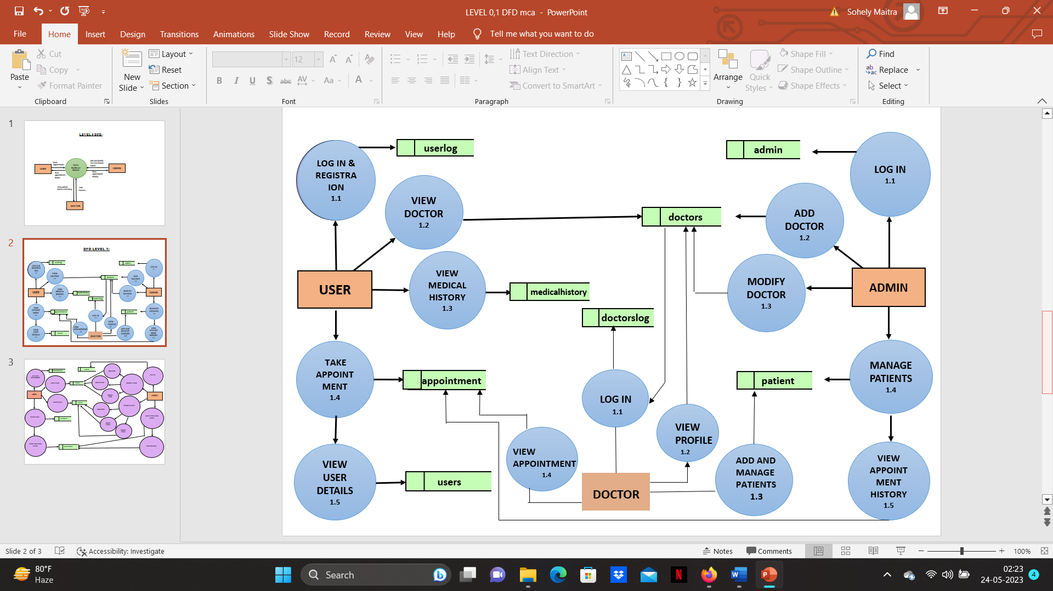**Level 1 DFD/Context Diagram**

**Chapter 4:PAGE DESIGN**

Index/Home

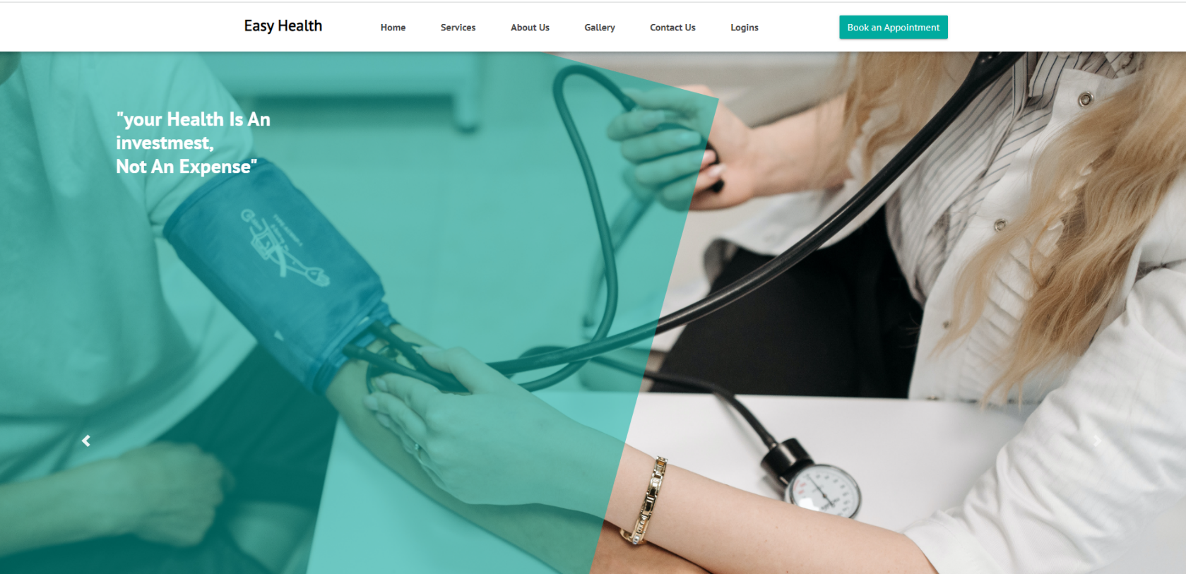

Services

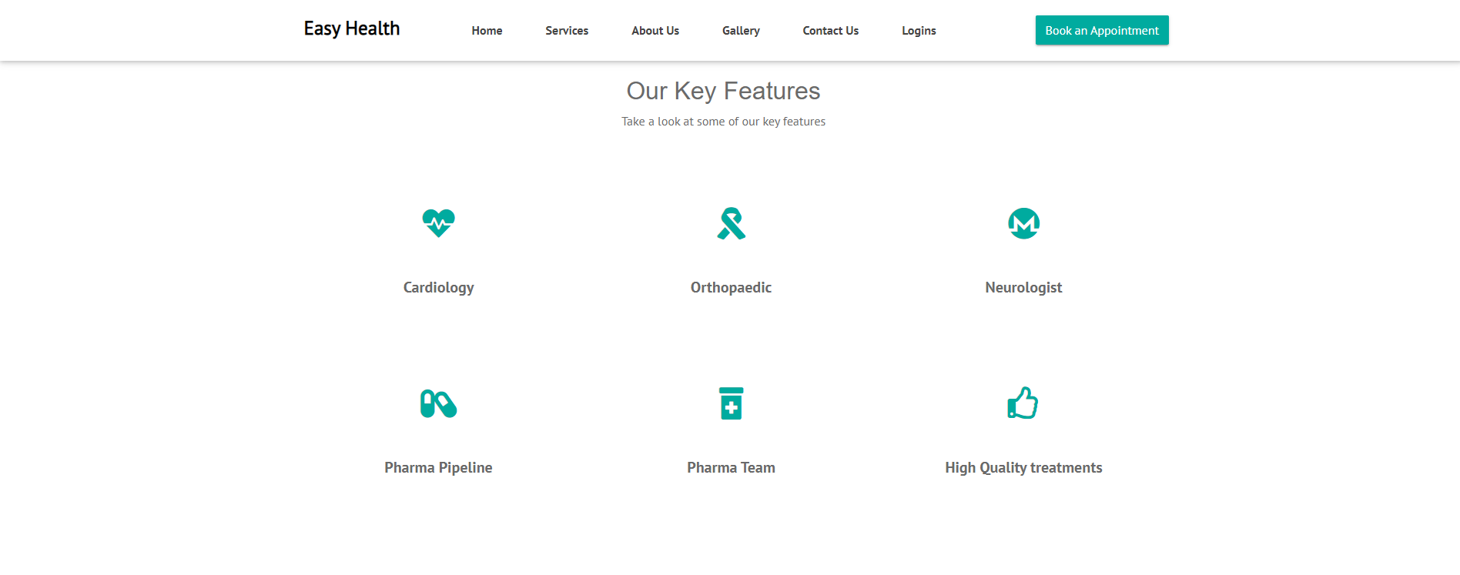

About

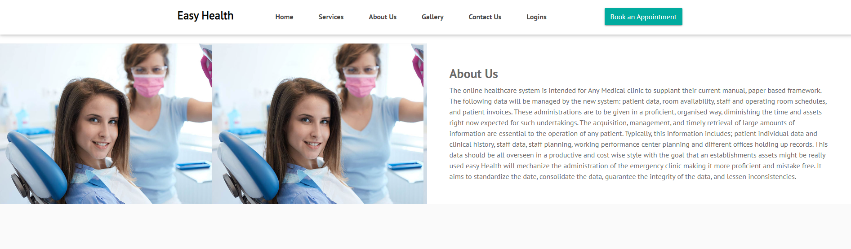

Gallery

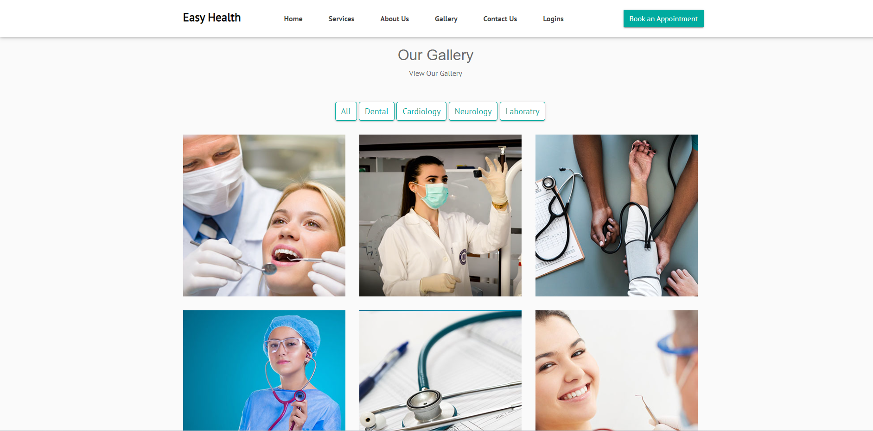

Contact

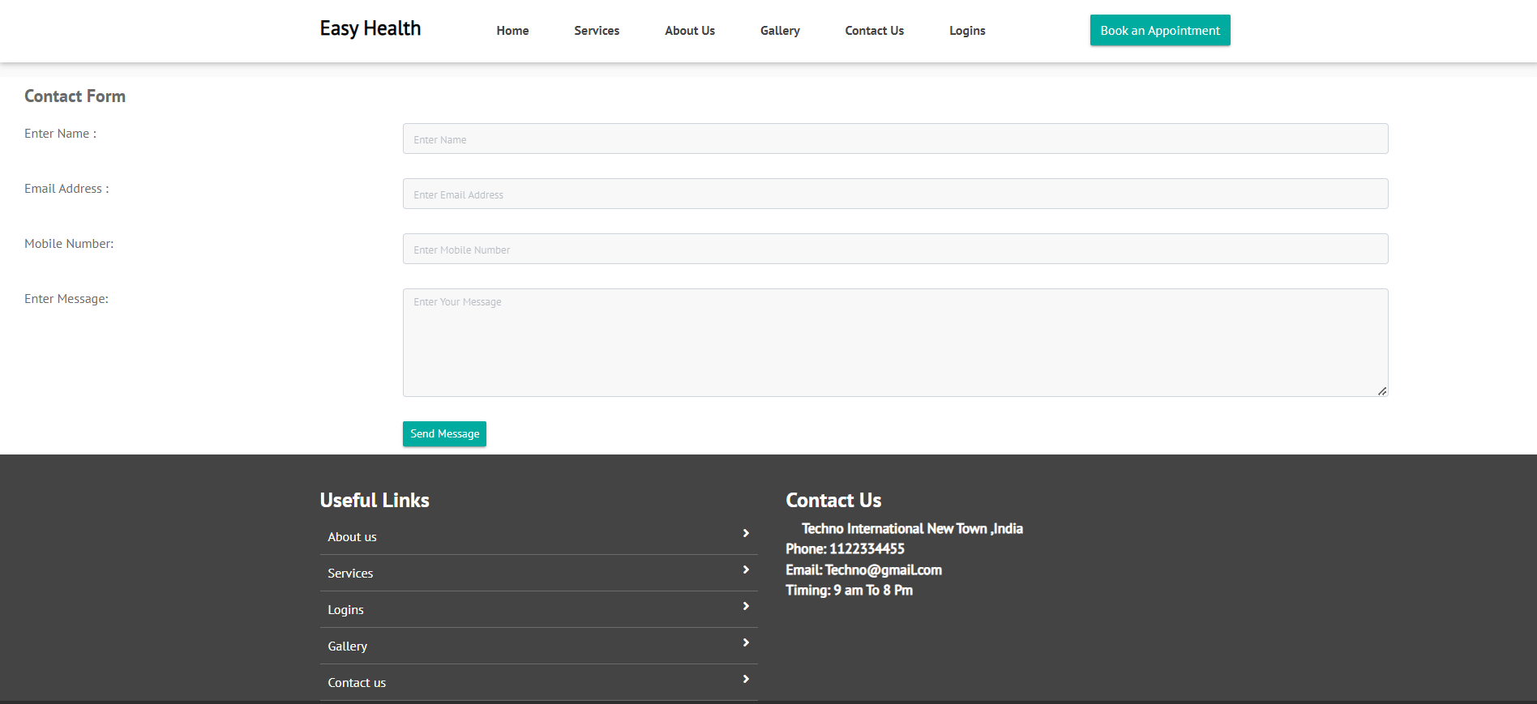

Login

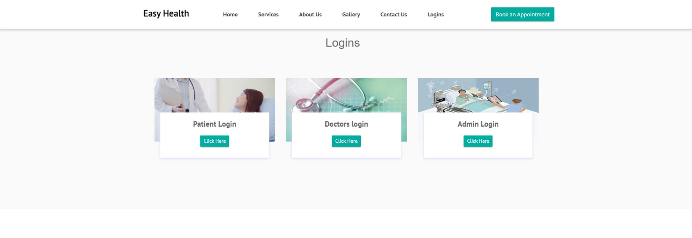

User Login

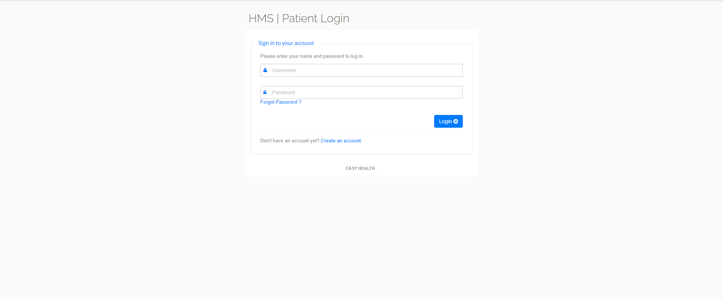

Registration

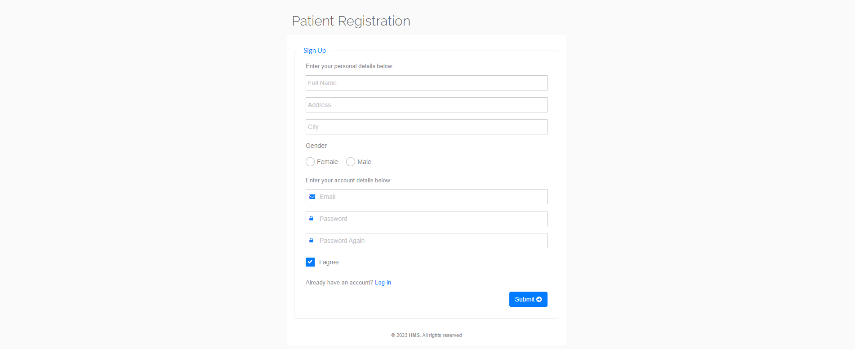

User Dashboard

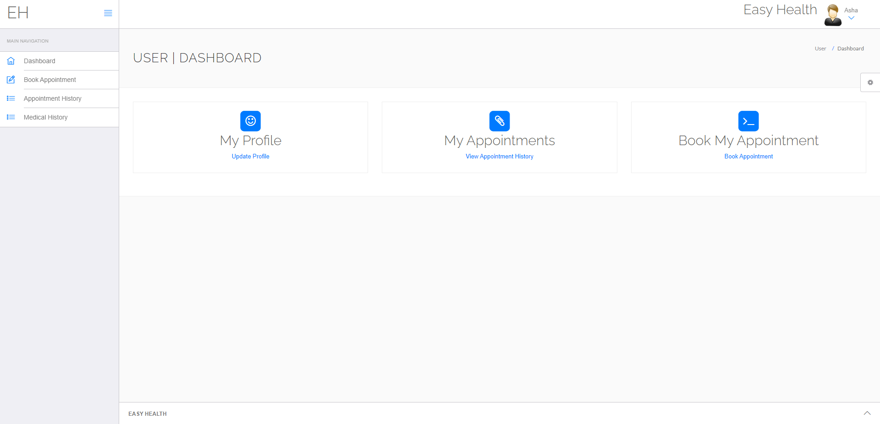

Doctor Appointment

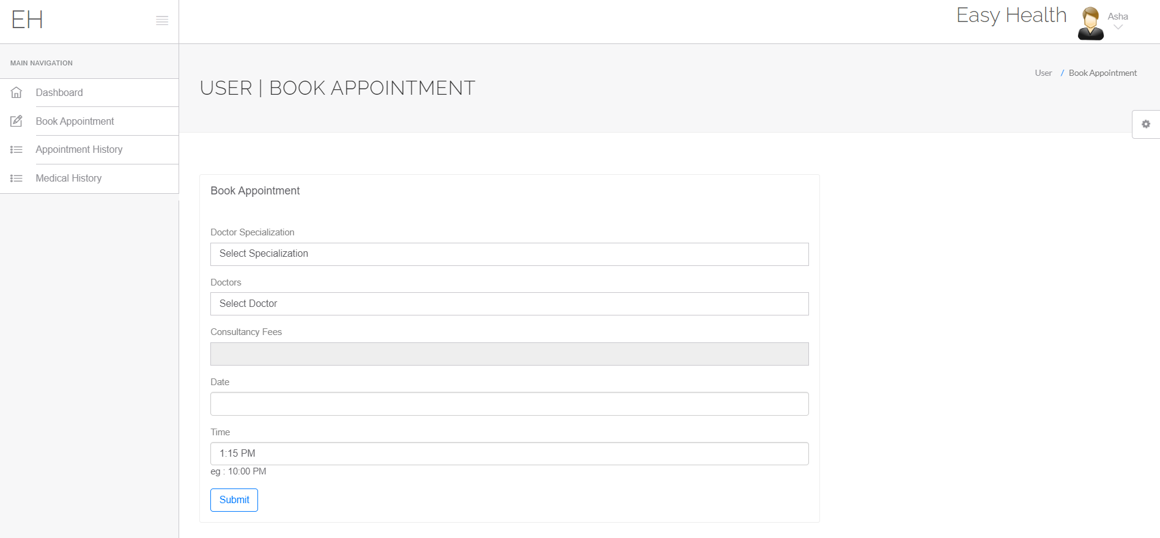

User Appointment History

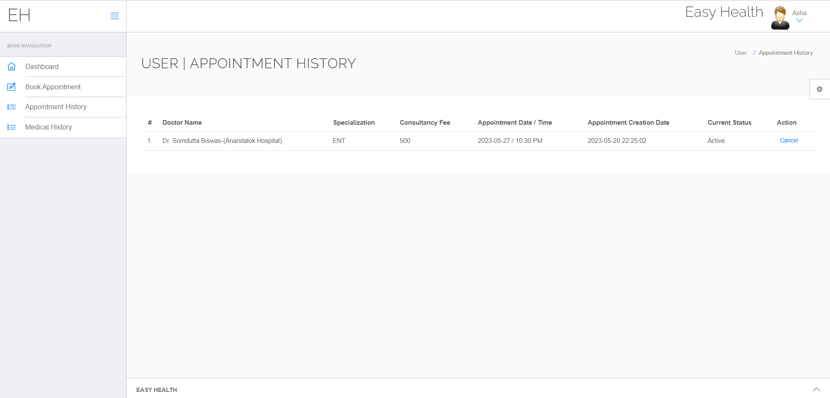

User Medical History

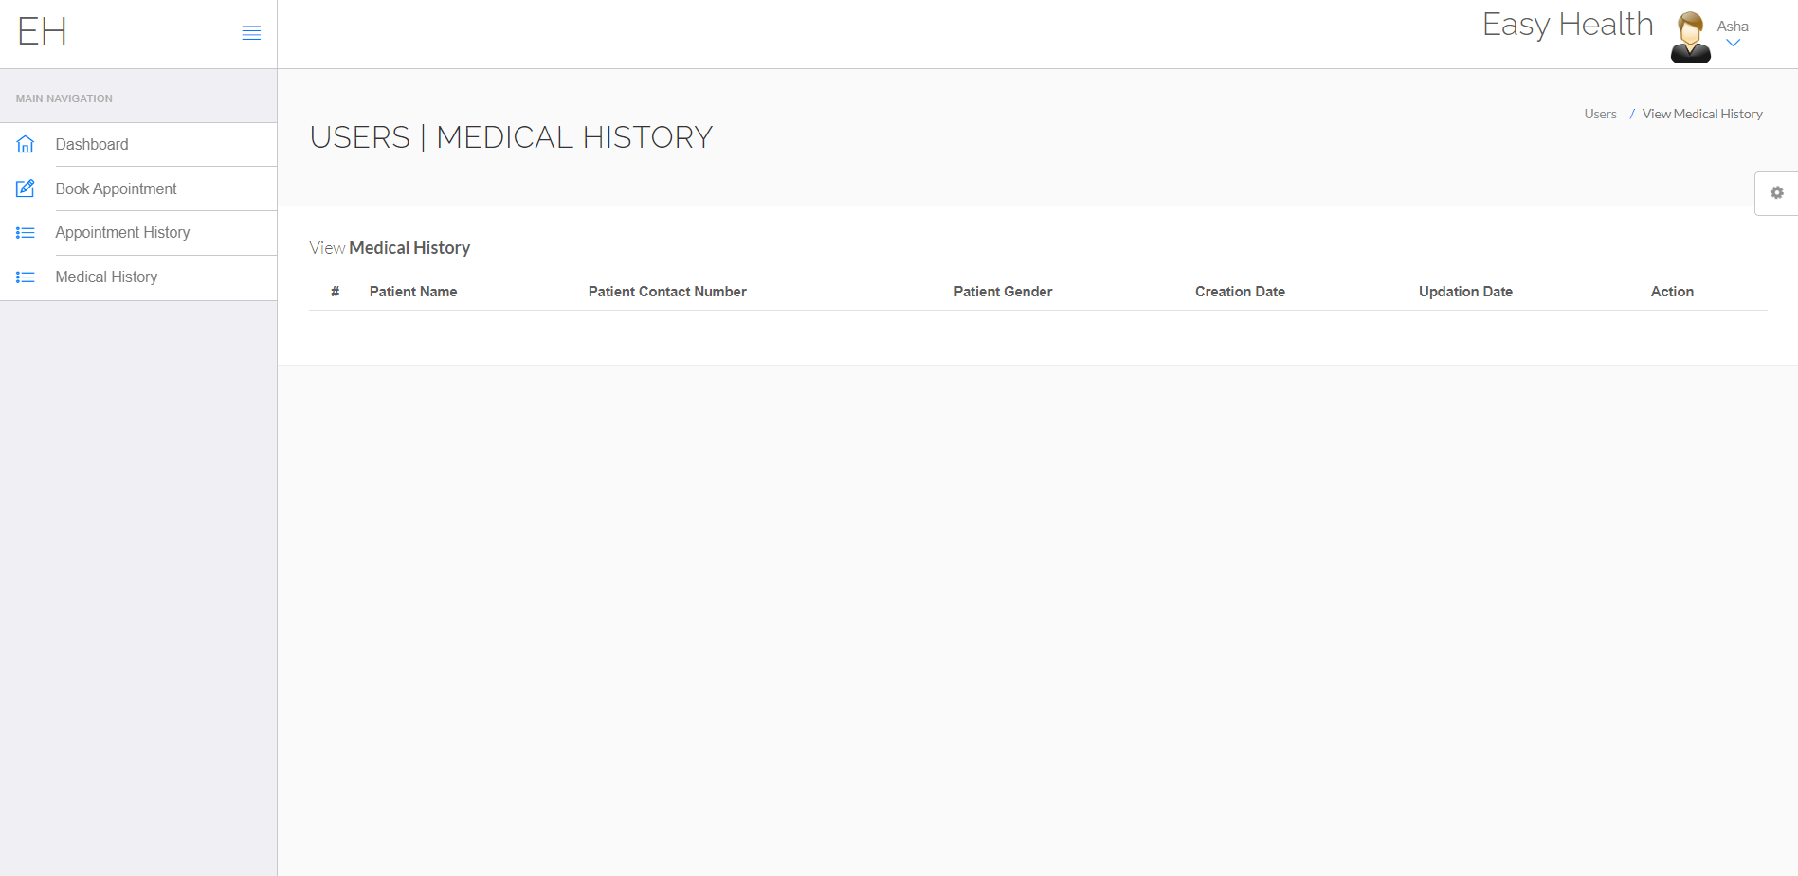

Doctor Dashboard

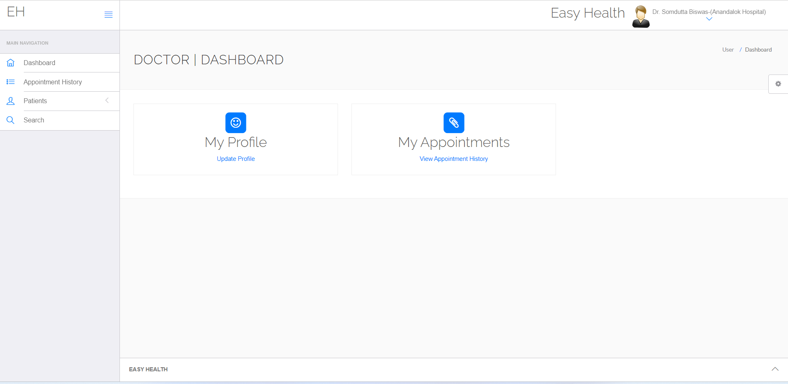

Appointment History

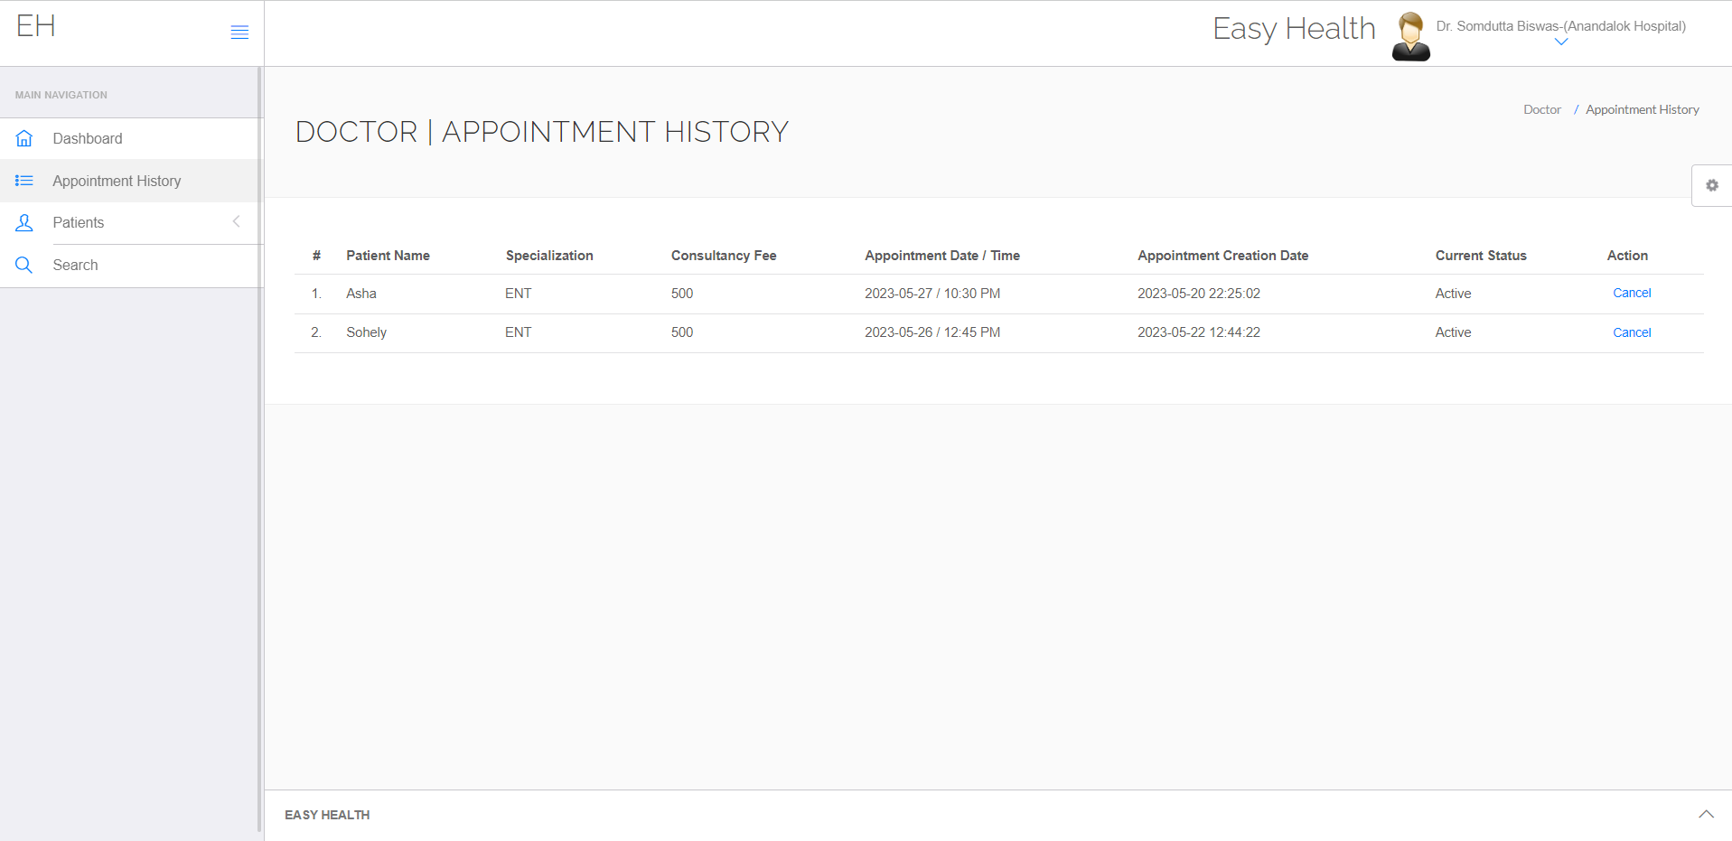

Add patient

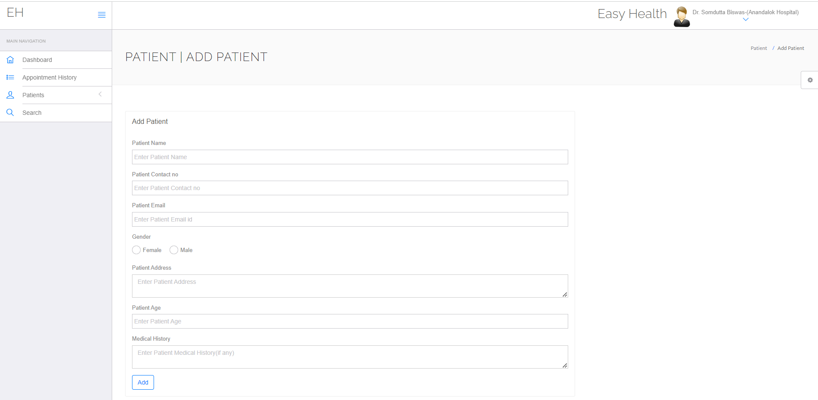

Doctor Manage Patient

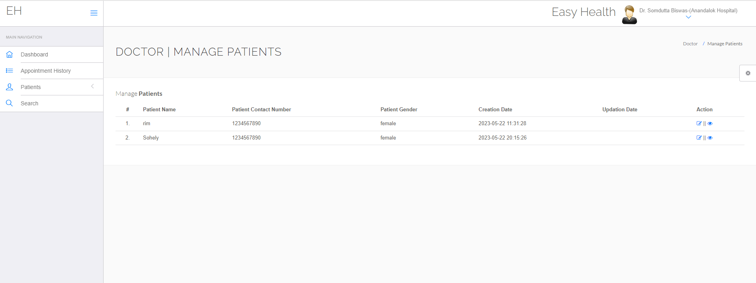

Doctor Add patient Medical History

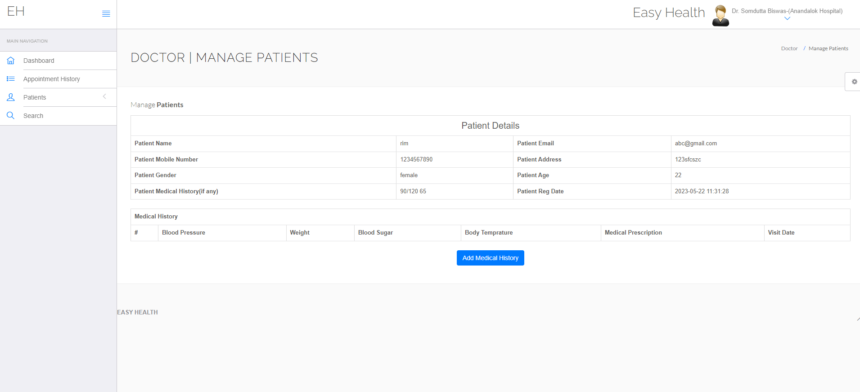

Admin Dashboard

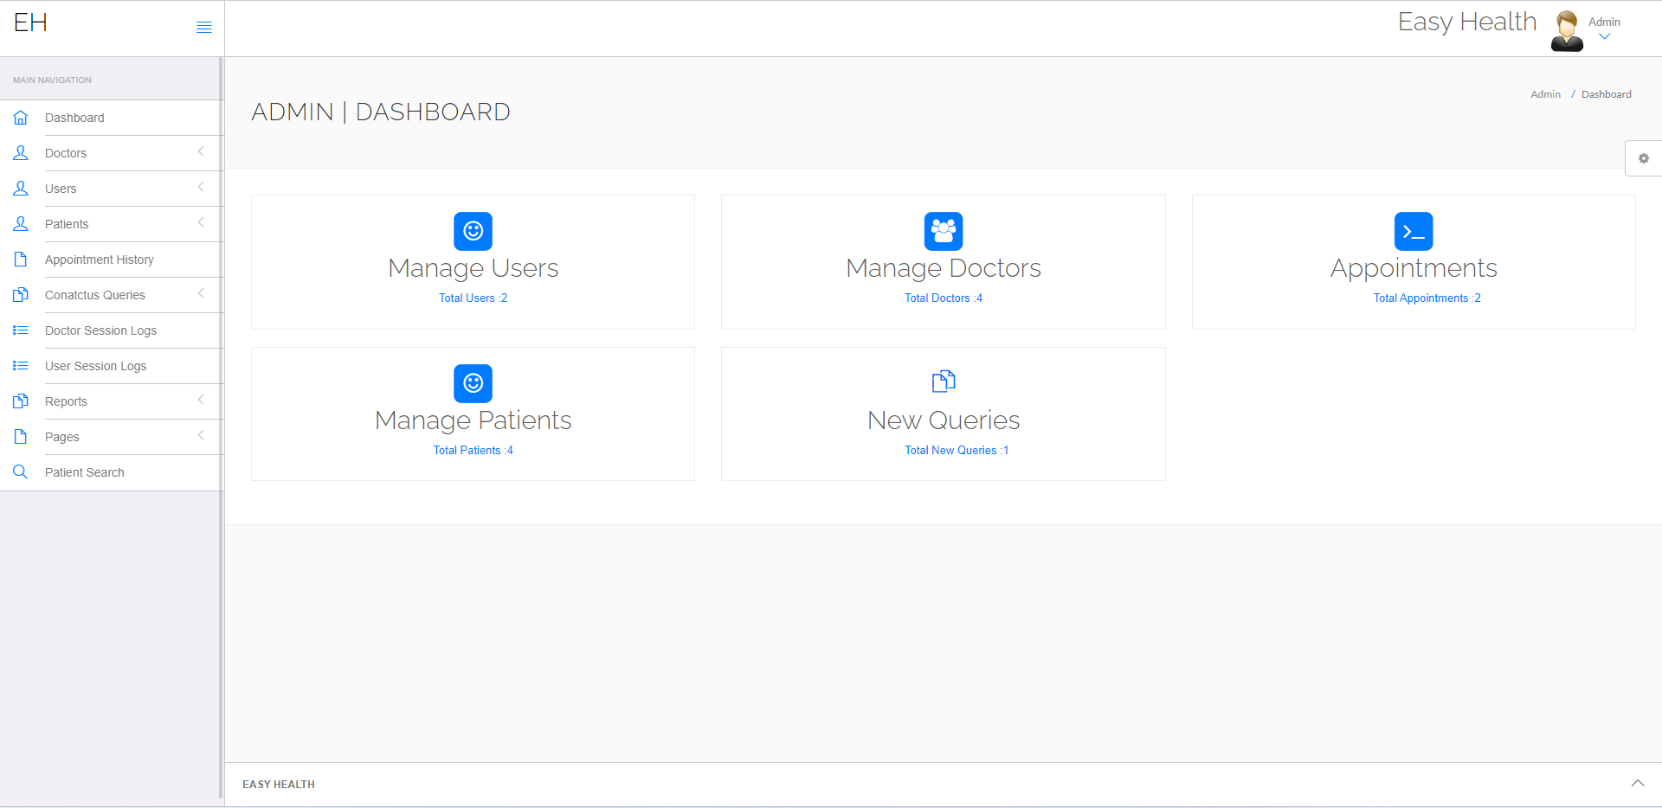

Admin add Doctors

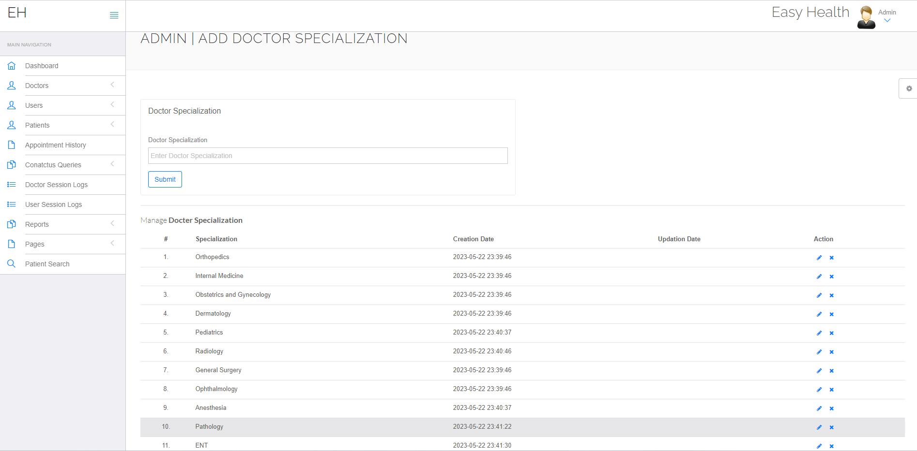

Admin Add Doctors

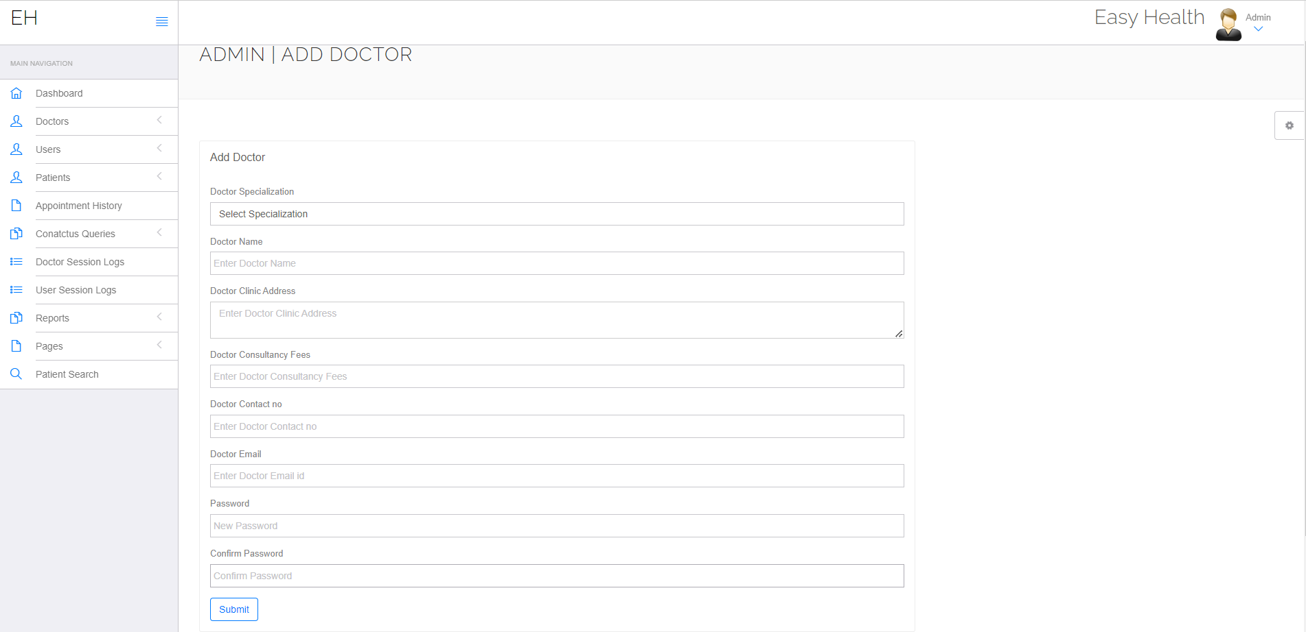

Admin Manage Doctors

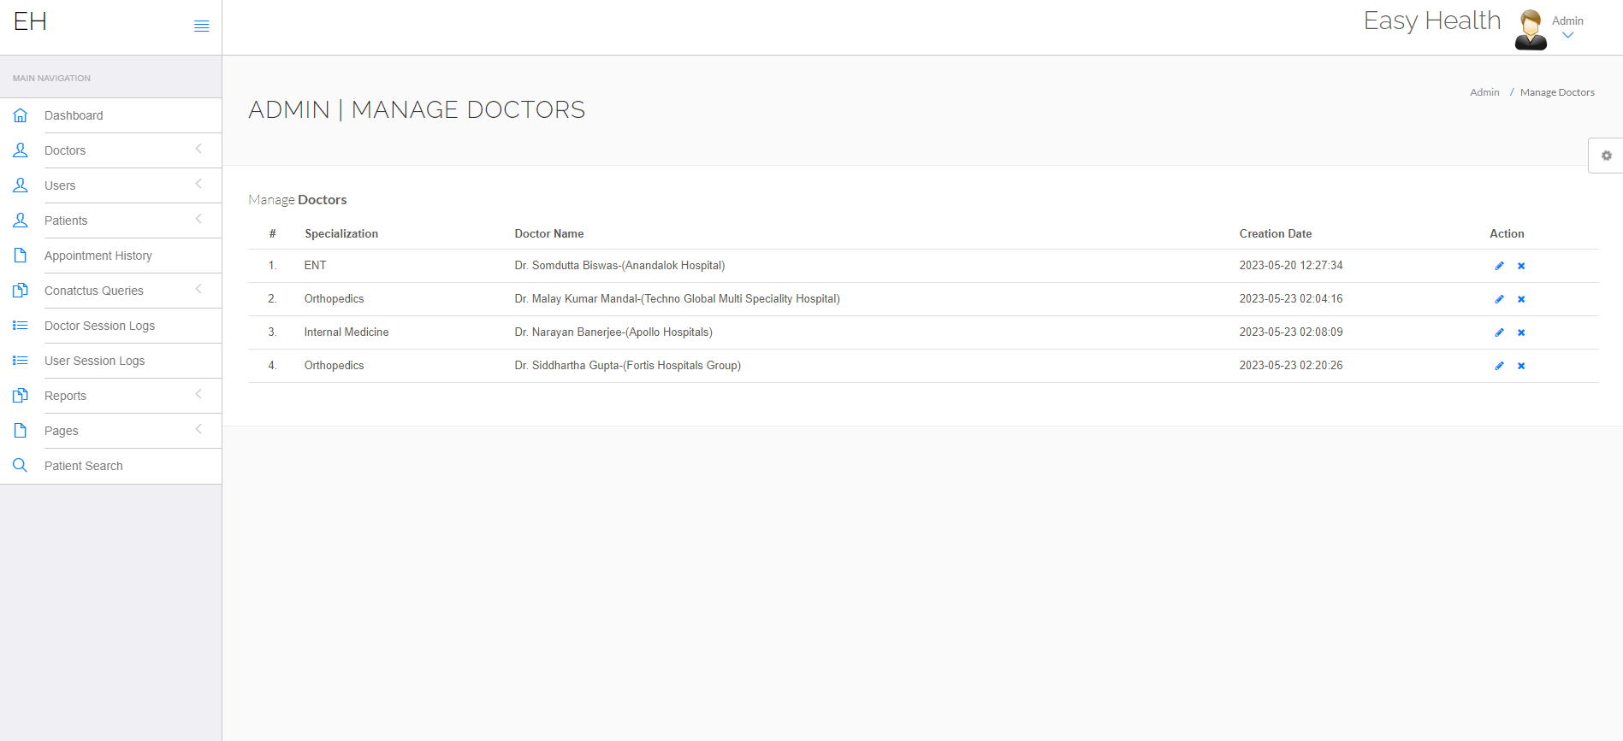

Admin Manage User

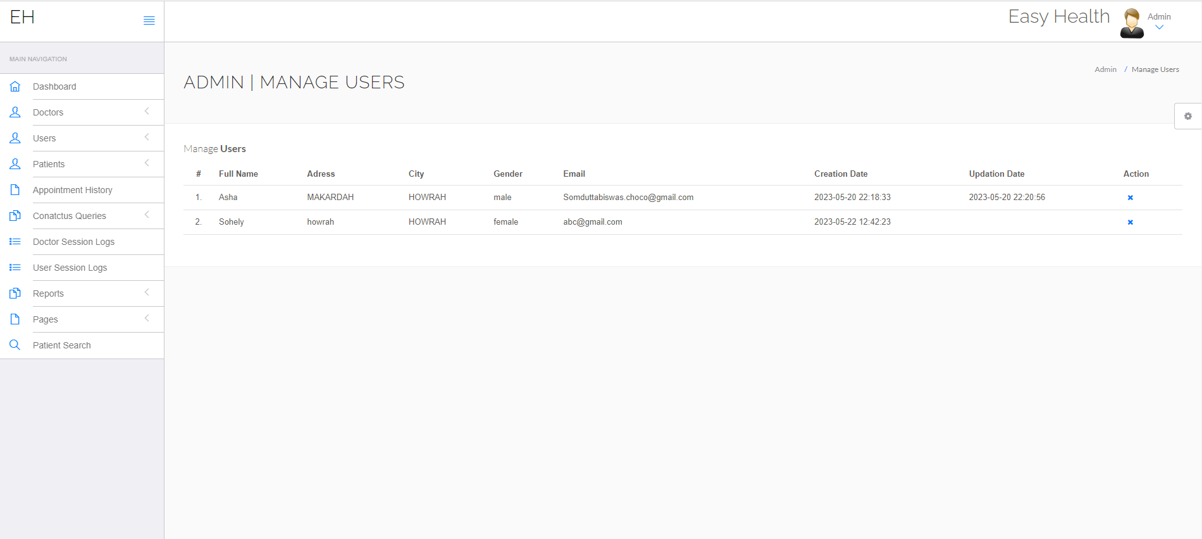

Admin View Patients

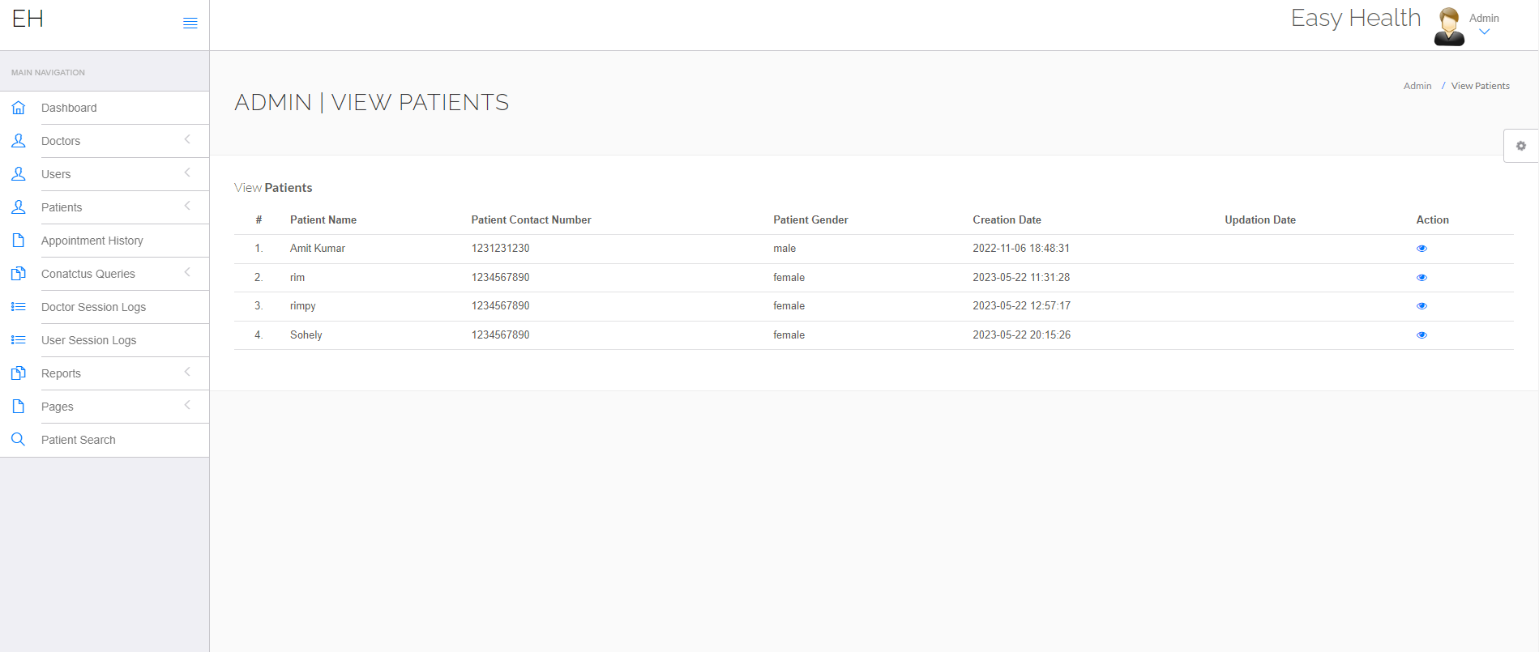

Admin Check Appointment History

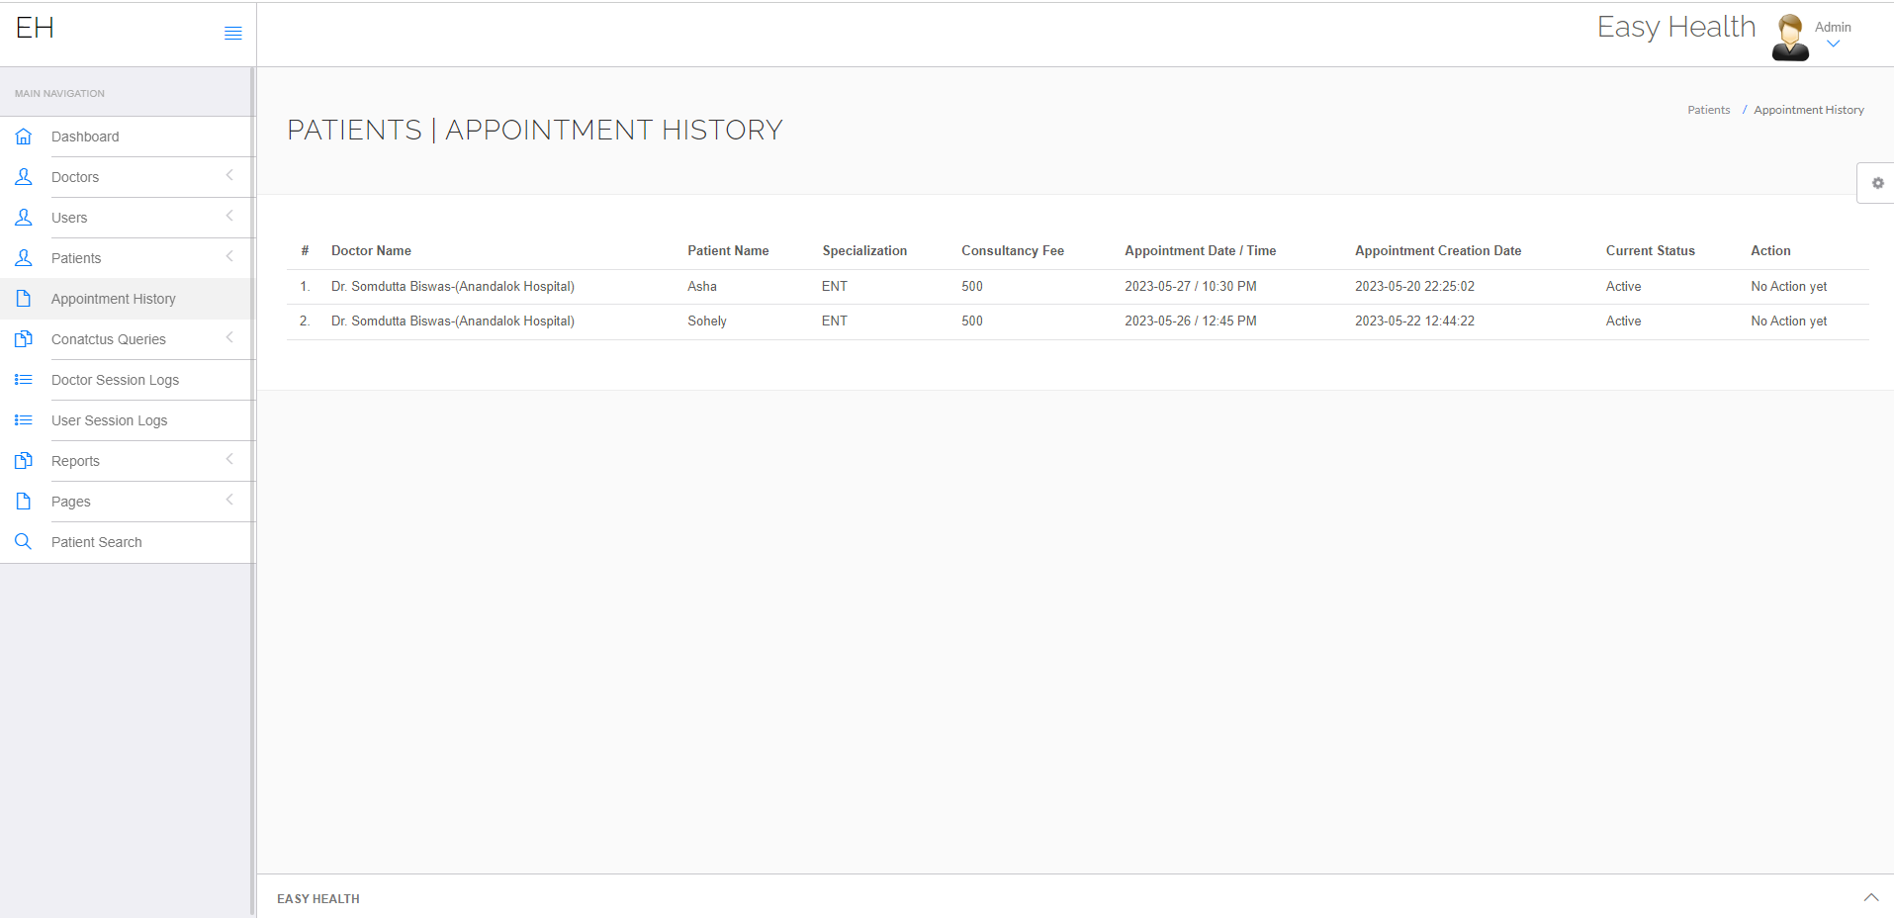

Admin Check Doctor Session login

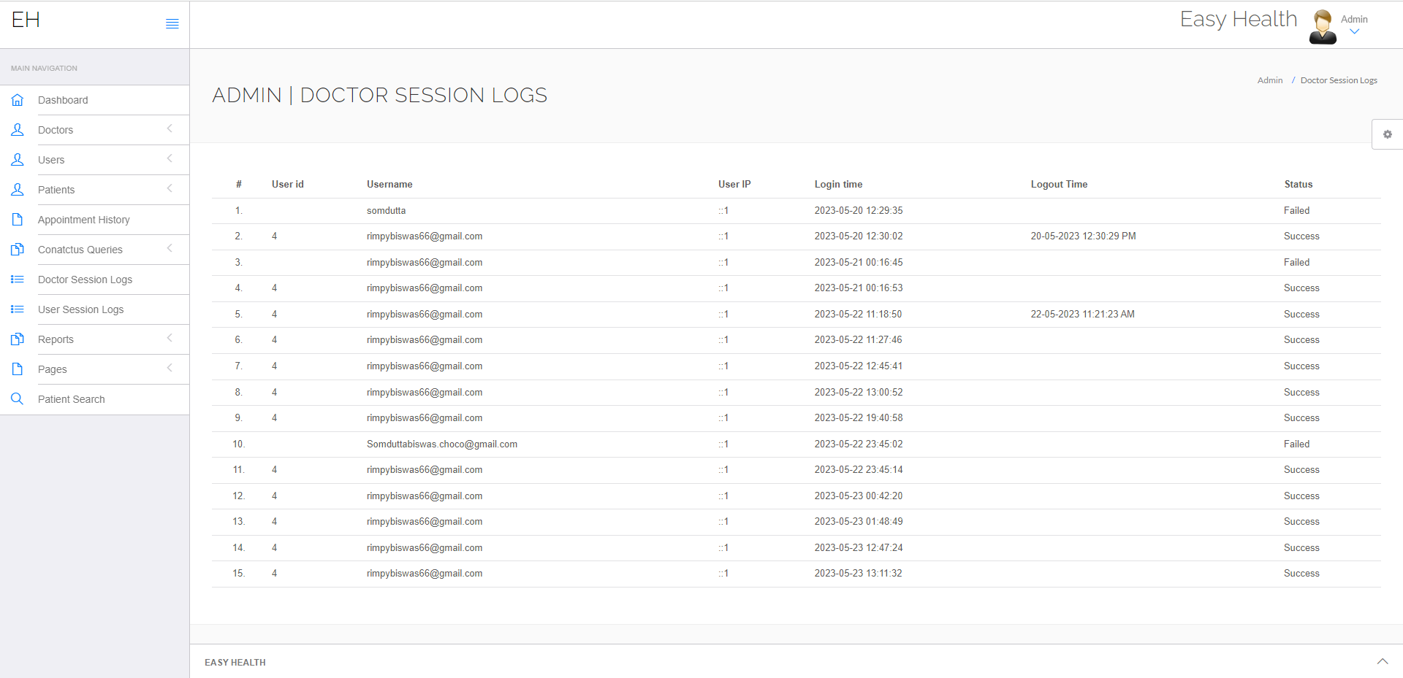

Admin Check User Session login

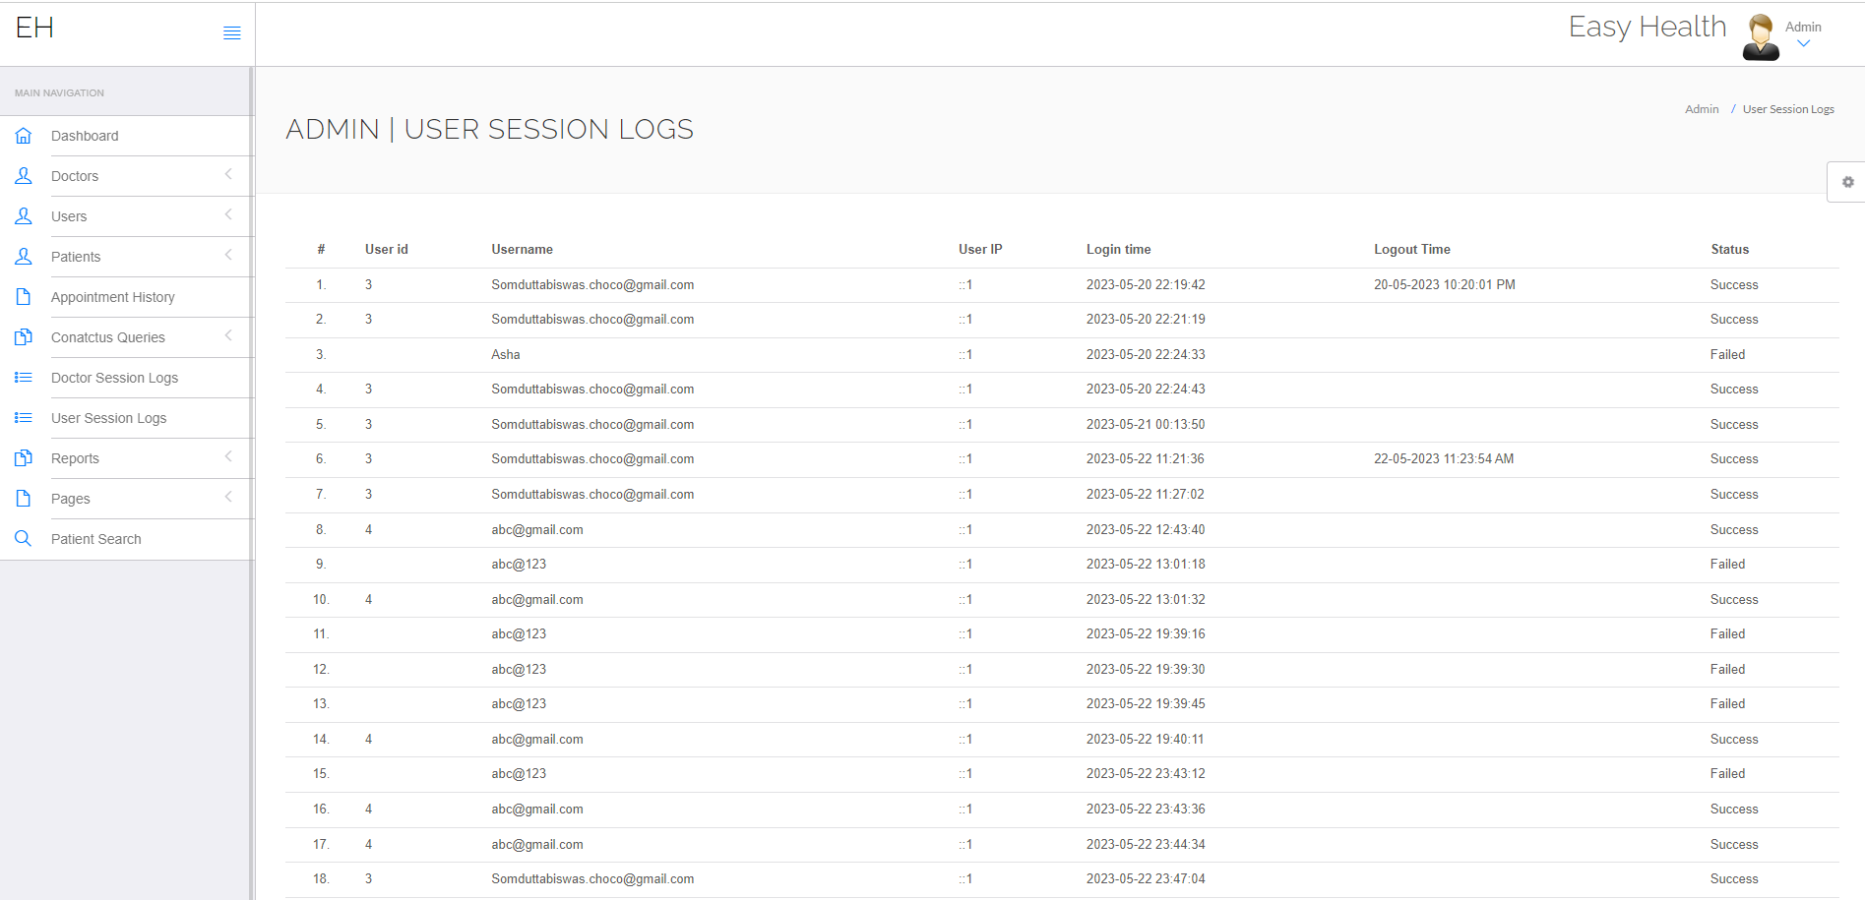

Data Base

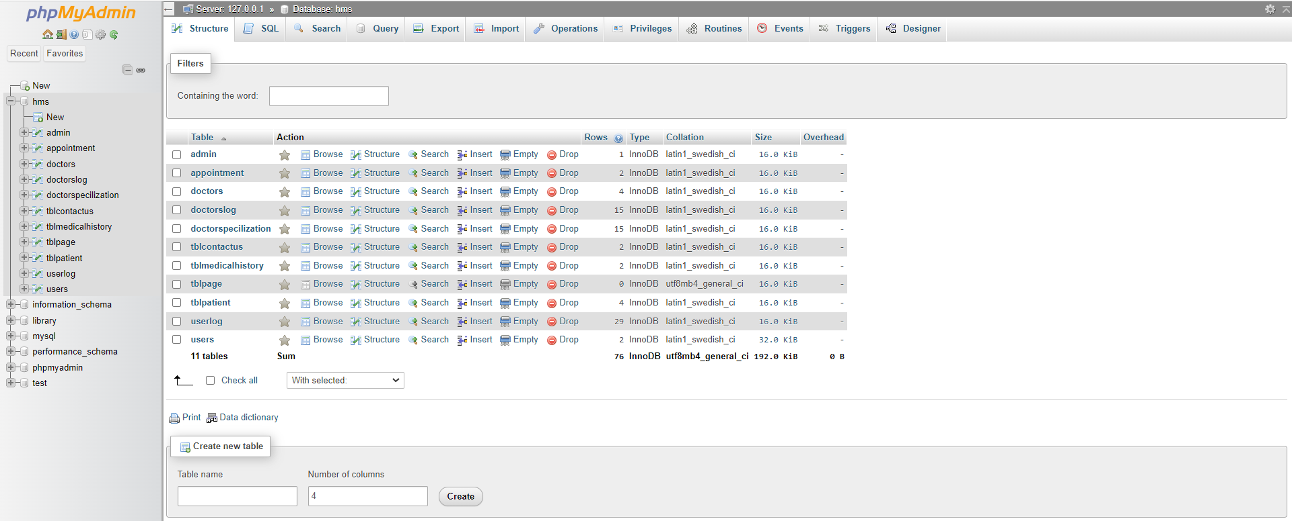

**Chapter 4:Source Code**

**Index Page:-**

<?php

include_once('hms/include/config.php');

if(isset($_POST['submit']))

{

$name=$_POST['fullname'];

$email=$_POST['emailid'];

$mobileno=$_POST['mobileno'];

$dscrption=$_POST['description'];

$query=mysqli_query($con,"insert into tblcontactus(fullname,email,contactno,message) value('$name','$email','$mobileno','$dscrption')");

echo "<script>alert('Your information succesfully submitted');</script>";

echo "<script>window.location.href ='index.php'</script>";

} ?>

<!doctype html>

<html lang="en">

<head>

<meta charset="utf-8">

<meta name="viewport" content="width=device-width, initial-scale=1, shrink-to-fit=no">

<title> Easy Health </title>

<link rel="shortcut icon" href="assets/images/fav.jpg">

<link rel="stylesheet" href="assets/css/bootstrap.min.css">

<link rel="stylesheet" href="assets/css/fontawsom-all.min.css">

<link rel="stylesheet" href="assets/css/animate.css">

<link rel="stylesheet" type="text/css" href="assets/css/style.css" />

</head>

<body>

<!-- ################# Header Starts Here#######################--->

<header id="menu-jk">

<div id="nav-head" class="header-nav">

<div class="container">

<div class="row">

<div class="col-lg-2 col-md-3 col-sm-12" style="color:#000;font-weight:bold; font-size:25px; margin-top: 1.7% !important;">Easy Health

<a data-toggle="collapse" data-target="#menu" href="#menu" ><i class="fas d-block d-md-none small-menu fa-bars"></i></a>

</div>

<div id="menu" class="col-lg-8 col-md-9 d-none d-md-block nav-item">

<ul>

<li><a href="#">Home</a></li>

<li><a href="#services">Services</a></li>

<li><a href="#about_us">About Us</a></li>

<li><a href="#gallery">Gallery</a></li>

<li><a href="#contact_us">Contact Us</a></li>

<li><a href="#logins">Logins</a></li>

</ul>

</div>

<div class="col-sm-2 d-none d-lg-block appoint">

<a class="btn btn-success" href="hms/user-login.php">Book an Appointment</a>

</div>

</div>

</div>

</div>

</header>

<!-- ################# Slider Starts Here#######################--->

<div class="slider-detail">

<div id="carouselExampleIndicators" class="carousel slide" data-ride="carousel">

<ol class="carousel-indicators">

<li data-target="#carouselExampleIndicators" data-slide-to="0" class="active"></li>

<li data-target="#carouselExampleIndicators" data-slide-to="1"></li>

</ol>

<div class="carousel-inner">

<div class="carousel-item ">

<img class="d-block w-100" src="assets/images/slider/slider_4.jpg" alt="Second slide">

<div class="carousel-cover"></div>

<div class="carousel-caption vdg-cur d-none d-md-block">

<h2 class="animated bounceInDown">"your Health Is An <br>investmest,<br> Not An Expense"</h2>

</div>

</div>

<div class="carousel-item active">

<img class="d-block w-100" src="assets/images/slider/slider_6.jpg" alt="Third slide">

<div class="carousel-cover"></div>

<div class="carousel-caption vdg-cur d-none d-md-block">

<p class="animated bounceInDown">Choose the experts in end to end care.</p>

<h2>You are in safe hands</h2>

</div>

</div>

</div>

<a class="carousel-control-prev" href="#carouselExampleIndicators" role="button" data-slide="prev">

<span class="carousel-control-prev-icon" aria-hidden="true"></span>

<span class="sr-only">Previous</span>

</a>

<a class="carousel-control-next" href="#carouselExampleIndicators" role="button" data-slide="next">

<span class="carousel-control-next-icon" aria-hidden="true"></span>

<span class="sr-only">Next</span>

</a>

</div>

</div>

<!-- ************************* Logins ************************** -->

<section id="logins" class="our-blog container-fluid">

<div class="container">

<div class="inner-title">

<h2>Logins</h2>

</div>

<div class="col-sm-12 blog-cont">

<div class="row no-margin">

<div class="col-sm-4 blog-smk">

<div class="blog-single">

<img src="assets/images/patient.jpg" alt="">

<div class="blog-single-det">

<h6>Patient Login</h6>

<a href="hms/user-login.php" target="_blank">

<button class="btn btn-success btn-sm">Click Here</button>

</a>

</div>

</div>

</div>

<div class="col-sm-4 blog-smk">

<div class="blog-single">

<img src="assets/images/doctor.jpg" alt="">

<div class="blog-single-det">

<h6>Doctors login</h6>

<a href="hms/doctor" target="_blank">

<button class="btn btn-success btn-sm">Click Here</button>

</a>

</div>

</div>

</div>

<div class="col-sm-4 blog-smk">

<div class="blog-single">

<img src="assets/images/admin.jpg" alt="">

<div class="blog-single-det">

<h6>Admin Login</h6>

<a href="hms/admin" target="_blank">

<button class="btn btn-success btn-sm">Click Here</button>

</a>

</div>

</div>

</div>

</div>

</div>

</div>

</section>

<!-- ################# Our Departments Starts Here#######################--->

<section id="services" class="key-features department">

<div class="container">

<div class="inner-title">

<h2>Our Key Features</h2>

<p>Take a look at some of our key features</p>

</div>

<div class="row">

<div class="col-lg-4 col-md-6">

<div class="single-key">

<i class="fas fa-heartbeat"></i>

<h5>Cardiology</h5>

</div>

</div>

<div class="col-lg-4 col-md-6">

<div class="single-key">

<i class="fas fa-ribbon"></i>

<h5>Orthopaedic</h5>

</div>

</div>

<div class="col-lg-4 col-md-6">

<div class="single-key">

<i class="fab fa-monero"></i>

<h5>Neurologist</h5>

</div>

</div>

<div class="col-lg-4 col-md-6">

<div class="single-key">

<i class="fas fa-capsules"></i>

<h5>Pharma Pipeline</h5>

</div>

</div>

<div class="col-lg-4 col-md-6">

<div class="single-key">

<i class="fas fa-prescription-bottle-alt"></i>

<h5>Pharma Team</h5>

</div>

</div>

<div class="col-lg-4 col-md-6">

<div class="single-key">

<i class="far fa-thumbs-up"></i>

<h5>High Quality treatments</h5>

</div>

</div>

</div>

</div>

</section>

<!-- ************************* About Us Starts Here ************************** -->

<section id="about_us" class="about-us">

<div class="row no-margin">

<div class="col-sm-6 image-bg no-padding">

</div>

<div class="col-sm-6 abut-yoiu">

<h3>About Us</h3>

<p> The online healthcare system is intended for Any Medical clinic to supplant their current manual, paper based framework. The following data will be managed by the new system: patient data, room availability, staff and operating room schedules, and patient invoices. These administrations are to be given in a proficient, organised way, diminishing the time and assets right now expected for such undertakings.

The acquisition, management, and timely retrieval of large amounts of information are essential to the operation of any patient. Typically, this information includes; patient individual data and clinical history, staff data, staff planning, working performance center planning and different offices holding up records. This data should be all overseen in a productive and cost wise style with the goal that an establishments assets might be really used easy Health will mechanize the administration of the emergency clinic making it more proficient and mistake free. It aims to standardize the date, consolidate the data, guarantee the integrity of the data, and lessen inconsistencies. </p>

<?php

$ret=mysqli_query($con,"select * from tblpage where PageType='aboutus' ");

while ($row=mysqli_fetch_array($ret)) {

?>

<p><?php echo $row['PageDescription'];?>.</p><?php } ?>

</div>

</div>

</section>

<!-- ************************* Gallery Starts Here ************************** -->

<div id="gallery" class="gallery">

<div class="container">

<div class="inner-title">

<h2>Our Gallery</h2>

<p>View Our Gallery</p>

</div>

<div class="row">

<div class="gallery-filter d-none d-sm-block">

<button class="btn btn-default filter-button" data-filter="all">All</button>

<button class="btn btn-default filter-button" data-filter="hdpe">Dental</button>

<button class="btn btn-default filter-button" data-filter="sprinkle">Cardiology</button>

<button class="btn btn-default filter-button" data-filter="spray"> Neurology</button>

<button class="btn btn-default filter-button" data-filter="irrigation">Laboratry</button>

</div>

<br/>

<div class="gallery_product col-lg-4 col-md-4 col-sm-4 col-xs-6 filter hdpe">

<img src="assets/images/gallery/gallery_01.jpg" class="img-responsive">

</div>

<div class="gallery_product col-lg-4 col-md-4 col-sm-4 col-xs-6 filter sprinkle">

<img src="assets/images/gallery/gallery_02.jpg" class="img-responsive">

</div>

<div class="gallery_product col-lg-4 col-md-4 col-sm-4 col-xs-6 filter hdpe">

<img src="assets/images/gallery/gallery_03.jpg" class="img-responsive">

</div>

<div class="gallery_product col-lg-4 col-md-4 col-sm-4 col-xs-6 filter irrigation">

<img src="assets/images/gallery/gallery_04.jpg" class="img-responsive">

</div>

<div class="gallery_product col-lg-4 col-md-4 col-sm-4 col-xs-6 filter spray">

<img src="assets/images/gallery/gallery_05.jpg" class="img-responsive">

</div>

<div class="gallery_product col-lg-4 col-md-4 col-sm-4 col-xs-6 filter spray">

<img src="assets/images/gallery/gallery_06.jpg" class="img-responsive">

</div>

</div>

</div>

</div>

<!-- ######## Gallery End ####### -->

<!-- ************************* Contact Us Starts Here ************************** -->

<section id="contact_us" class="contact-us-single">

<div class="row no-margin">

<div class="col-sm-12 cop-ck">

<form method="post">

<h2 >Contact Form</h2>

<div class="row cf-ro">

<div class="col-sm-3"><label>Enter Name :</label></div>

<div class="col-sm-8"><input type="text" placeholder="Enter Name" name="fullname" class="form-control input-sm" required ></div>

</div>

<div class="row cf-ro">

<div class="col-sm-3"><label>Email Address :</label></div>

<div class="col-sm-8"><input type="text" name="emailid" placeholder="Enter Email Address" class="form-control input-sm" required></div>

</div>

<div class="row cf-ro">

<div class="col-sm-3"><label>Mobile Number:</label></div>

<div class="col-sm-8"><input type="text" name="mobileno" placeholder="Enter Mobile Number" class="form-control input-sm" required ></div>

</div>

<div class="row cf-ro">

<div class="col-sm-3"><label>Enter Message:</label></div>

<div class="col-sm-8">

<textarea rows="5" placeholder="Enter Your Message" class="form-control input-sm" name="description" required></textarea>

</div>

</div>

<div class="row cf-ro">

<div class="col-sm-3"><label></label></div>

<div class="col-sm-8">

<button class="btn btn-success btn-sm" type="submit" name="submit">Send Message</button>

</div>

</div>

</form>

</div>

</div>

</section>

<!-- ################# Footer Starts Here#######################--->

<footer class="footer">

<div class="container">

<div class="row">

<div class="col-md-6 col-sm-12">

<h2>Useful Links</h2>

<ul class="list-unstyled link-list">

<li><a ui-sref="about" href="#about">About us</a><i class="fa fa-angle-right"></i></li>

<li><a ui-sref="portfolio" href="#services">Services</a><i class="fa fa-angle-right"></i></li>

<li><a ui-sref="products" href="#logins">Logins</a><i class="fa fa-angle-right"></i></li>

<li><a ui-sref="gallery" href="#gallery">Gallery</a><i class="fa fa-angle-right"></i></li>

<li><a ui-sref="contact" href="#contact">Contact us</a><i class="fa fa-angle-right"></i></li>

</ul>

</div>

<div class="col-md-6 col-sm-12 map-img">

<h2>Contact Us</h2>

<address class="md-margin-bottom-40">

<p> Techno International New Town ,India<br>

Phone: 1122334455<br>

Email: Techno@gmail.com<br>

Timing: 9 am To 8 Pm </p>

<?php

$ret=mysqli_query($con,"select * from tblpage where PageType='contactus' ");

while ($row=mysqli_fetch_array($ret)) {

?>

<?php echo $row['PageDescription'];?> <br>

Phone: <?php echo $row['MobileNumber'];?> <br>

Email: <a href="mailto:<?php echo $row['Email'];?>" class=""><?php echo $row['Email'];?></a><br>

Timing: <?php echo $row['OpenningTime'];?>

</address>

<?php } ?>

</div>

</div>

</div>

</footer>

<div class="copy">

<div class="container">

Easy Health

</div>

</div>

</body>

<script src="assets/js/jquery-3.2.1.min.js"></script>

<script src="assets/js/popper.min.js"></script>

<script src="assets/js/bootstrap.min.js"></script>

<script src="assets/plugins/scroll-nav/js/jquery.easing.min.js"></script>

<script src="assets/plugins/scroll-nav/js/scrolling-nav.js"></script>

<script src="assets/plugins/scroll-fixed/jquery-scrolltofixed-min.js"></script>

<script src="assets/js/script.js"></script>

</html>

**User Dashbord:-**

<?php

session_start();

//error_reporting(0);

include('include/config.php');

include('include/checklogin.php');

check_login();

?>

<!DOCTYPE html>

<html lang="en">

<head>

<title>User | Dashboard</title>

<link href="http://fonts.googleapis.com/css?family=Lato:300,400,400italic,600,700|Raleway:300,400,500,600,700|Crete+Round:400italic" rel="stylesheet" type="text/css" />

<link rel="stylesheet" href="vendor/bootstrap/css/bootstrap.min.css">

<link rel="stylesheet" href="vendor/fontawesome/css/font-awesome.min.css">

<link rel="stylesheet" href="vendor/themify-icons/themify-icons.min.css">

<link href="vendor/animate.css/animate.min.css" rel="stylesheet" media="screen">

<link href="vendor/perfect-scrollbar/perfect-scrollbar.min.css" rel="stylesheet" media="screen">

<link href="vendor/switchery/switchery.min.css" rel="stylesheet" media="screen">

<link href="vendor/bootstrap-touchspin/jquery.bootstrap-touchspin.min.css" rel="stylesheet" media="screen">

<link href="vendor/select2/select2.min.css" rel="stylesheet" media="screen">

<link href="vendor/bootstrap-datepicker/bootstrap-datepicker3.standalone.min.css" rel="stylesheet" media="screen">

<link href="vendor/bootstrap-timepicker/bootstrap-timepicker.min.css" rel="stylesheet" media="screen">

<link rel="stylesheet" href="assets/css/styles.css">

<link rel="stylesheet" href="assets/css/plugins.css">

<link rel="stylesheet" href="assets/css/themes/theme-1.css" id="skin_color" />

</head>

<body>

<div id="app">

<?php include('include/sidebar.php');?>

<div class="app-content">

<?php include('include/header.php');?>

<!-- end: TOP NAVBAR -->

<div class="main-content" >

<div class="wrap-content container" id="container">

<!-- start: PAGE TITLE -->

<section id="page-title">

<div class="row">

<div class="col-sm-8">

<h1 class="mainTitle">User | Dashboard</h1>

</div>

<ol class="breadcrumb">

<li>

<span>User</span>

</li>

<li class="active">

<span>Dashboard</span>

</li>

</ol>

</div>

</section>

<!-- end: PAGE TITLE -->

<!-- start: BASIC EXAMPLE -->

<div class="container-fluid container-fullw bg-white">

<div class="row">

<div class="col-sm-4">

<div class="panel panel-white no-radius text-center">

<div class="panel-body">

<span class="fa-stack fa-2x"> <i class="fa fa-square fa-stack-2x text-primary"></i> <i class="fa fa-smile-o fa-stack-1x fa-inverse"></i> </span>

<h2 class="StepTitle">My Profile</h2>

<p class="links cl-effect-1">

<a href="edit-profile.php">

Update Profile

</a>

</p>

</div>

</div>

</div>

<div class="col-sm-4">

<div class="panel panel-white no-radius text-center">

<div class="panel-body">

<span class="fa-stack fa-2x"> <i class="fa fa-square fa-stack-2x text-primary"></i> <i class="fa fa-paperclip fa-stack-1x fa-inverse"></i> </span>

<h2 class="StepTitle">My Appointments</h2>

<p class="cl-effect-1">

<a href="appointment-history.php">

View Appointment History

</a>

</p>

</div>

</div>

</div>

<div class="col-sm-4">

<div class="panel panel-white no-radius text-center">

<div class="panel-body">

<span class="fa-stack fa-2x"> <i class="fa fa-square fa-stack-2x text-primary"></i> <i class="fa fa-terminal fa-stack-1x fa-inverse"></i> </span>

<h2 class="StepTitle"> Book My Appointment</h2>

<p class="links cl-effect-1">

<a href="book-appointment.php">

Book Appointment

</a>

</p>

</div>

</div>

</div>

</div>

</div>

<!-- end: SELECT BOXES -->

</div>

</div>

</div>

<!-- start: FOOTER -->

<?php include('include/footer.php');?>

<!-- end: FOOTER -->

<!-- start: SETTINGS -->

<?php include('include/setting.php');?>

<>

<!-- end: SETTINGS -->

</div>

<!-- start: MAIN JAVASCRIPTS -->

<script src="vendor/jquery/jquery.min.js"></script>

<script src="vendor/bootstrap/js/bootstrap.min.js"></script>

<script src="vendor/modernizr/modernizr.js"></script>

<script src="vendor/jquery-cookie/jquery.cookie.js"></script>

<script src="vendor/perfect-scrollbar/perfect-scrollbar.min.js"></script>

<script src="vendor/switchery/switchery.min.js"></script>

<!-- end: MAIN JAVASCRIPTS -->

<!-- start: JAVASCRIPTS REQUIRED FOR THIS PAGE ONLY -->

<script src="vendor/maskedinput/jquery.maskedinput.min.js"></script>

<script src="vendor/bootstrap-touchspin/jquery.bootstrap-touchspin.min.js"></script>

<script src="vendor/autosize/autosize.min.js"></script>

<script src="vendor/selectFx/classie.js"></script>

<script src="vendor/selectFx/selectFx.js"></script>

<script src="vendor/select2/select2.min.js"></script>

<script src="vendor/bootstrap-datepicker/bootstrap-datepicker.min.js"></script>

<script src="vendor/bootstrap-timepicker/bootstrap-timepicker.min.js"></script>

<!-- end: JAVASCRIPTS REQUIRED FOR THIS PAGE ONLY -->

<!-- start: CLIP-TWO JAVASCRIPTS -->

<script src="assets/js/main.js"></script>

<!-- start: JavaScript Event Handlers for this page -->

<script src="assets/js/form-elements.js"></script>

<script>

jQuery(document).ready(function() {

Main.init();

FormElements.init();

});

</script>

<!-- end: JavaScript Event Handlers for this page -->

<!-- end: CLIP-TWO JAVASCRIPTS -->

</body>

</html>

**Appointment:-**

<?php

session_start();

error_reporting(0);

include('include/config.php');

if(strlen($_SESSION['id']==0)) {

header('location:logout.php');

} else{

if(isset($_GET['cancel']))

{

mysqli_query($con,"update appointment set userStatus='0' where id = '".$_GET['id']."'");

$_SESSION['msg']="Your appointment canceled !!";

}

?>

<!DOCTYPE html>

<html lang="en">

<head>

<title>User | Appointment History</title>

<link href="http://fonts.googleapis.com/css?family=Lato:300,400,400italic,600,700|Raleway:300,400,500,600,700|Crete+Round:400italic" rel="stylesheet" type="text/css" />

<link rel="stylesheet" href="vendor/bootstrap/css/bootstrap.min.css">

<link rel="stylesheet" href="vendor/fontawesome/css/font-awesome.min.css">

<link rel="stylesheet" href="vendor/themify-icons/themify-icons.min.css">

<link href="vendor/animate.css/animate.min.css" rel="stylesheet" media="screen">

<link href="vendor/perfect-scrollbar/perfect-scrollbar.min.css" rel="stylesheet" media="screen">

<link href="vendor/switchery/switchery.min.css" rel="stylesheet" media="screen">

<link href="vendor/bootstrap-touchspin/jquery.bootstrap-touchspin.min.css" rel="stylesheet" media="screen">

<link href="vendor/select2/select2.min.css" rel="stylesheet" media="screen">

<link href="vendor/bootstrap-datepicker/bootstrap-datepicker3.standalone.min.css" rel="stylesheet" media="screen">

<link href="vendor/bootstrap-timepicker/bootstrap-timepicker.min.css" rel="stylesheet" media="screen">

<link rel="stylesheet" href="assets/css/styles.css">

<link rel="stylesheet" href="assets/css/plugins.css">

<link rel="stylesheet" href="assets/css/themes/theme-1.css" id="skin_color" />

</head>

<body>

<div id="app">

<?php include('include/sidebar.php');?>

<div class="app-content">

<?php include('include/header.php');?>

<!-- end: TOP NAVBAR -->

<div class="main-content" >

<div class="wrap-content container" id="container">

<!-- start: PAGE TITLE -->

<section id="page-title">

<div class="row">

<div class="col-sm-8">

<h1 class="mainTitle">User | Appointment History</h1>

</div>

<ol class="breadcrumb">

<li>

<span>User </span>

</li>

<li class="active">

<span>Appointment History</span>

</li>

</ol>

</div>

</section>

<!-- end: PAGE TITLE -->

<!-- start: BASIC EXAMPLE -->

<div class="container-fluid container-fullw bg-white">

<div class="row">

<div class="col-md-12">

<p style="color:red;"><?php echo htmlentities($_SESSION['msg']);?>

<?php echo htmlentities($_SESSION['msg']="");?></p>

<table class="table table-hover" id="sample-table-1">

<thead>

<tr>

<th class="center">#</th>

<th class="hidden-xs">Doctor Name</th>

<th>Specialization</th>

<th>Consultancy Fee</th>

<th>Appointment Date / Time </th>

<th>Appointment Creation Date </th>

<th>Current Status</th>

<th>Action</th>

</tr>

</thead>

<tbody>

<?php

$sql=mysqli_query($con,"select doctors.doctorName as docname,appointment.* from appointment join doctors on doctors.id=appointment.doctorId where appointment.userId='".$_SESSION['id']."'");

$cnt=1;

while($row=mysqli_fetch_array($sql))

{

?>

<tr>

<td class="center"><?php echo $cnt;?>.</td>

<td class="hidden-xs"><?php echo $row['docname'];?></td>

<td><?php echo $row['doctorSpecialization'];?></td>

<td><?php echo $row['consultancyFees'];?></td>

<td><?php echo $row['appointmentDate'];?> / <?php echo

$row['appointmentTime'];?>

</td>

<td><?php echo $row['postingDate'];?></td>

<td>

<?php if(($row['userStatus']==1) && ($row['doctorStatus']==1))

{

echo "Active";

}

if(($row['userStatus']==0) && ($row['doctorStatus']==1))

{

echo "Cancel by You";

}

if(($row['userStatus']==1) && ($row['doctorStatus']==0))

{

echo "Cancel by Doctor";

}

?></td>

<td >

<div class="visible-md visible-lg hidden-sm hidden-xs">

<?php if(($row['userStatus']==1) && ($row['doctorStatus']==1))

{ ?>

<a href="appointment-history.php?id=<?php echo $row['id']?>&cancel=update" onClick="return confirm('Are you sure you want to cancel this appointment ?')"class="btn btn-transparent btn-xs tooltips" title="Cancel Appointment" tooltip-placement="top" tooltip="Remove">Cancel</a>

<?php } else {

echo "Canceled";

} ?>

</div>

<div class="visible-xs visible-sm hidden-md hidden-lg">

<div class="btn-group" dropdown is-open="status.isopen">

<button type="button" class="btn btn-primary btn-o btn-sm dropdown-toggle" dropdown-toggle>

<i class="fa fa-cog"></i>&nbsp;<span class="caret"></span>

</button>

<ul class="dropdown-menu pull-right dropdown-light" role="menu">

<li>

<a href="#">

Edit

</a>

</li>

<li>

<a href="#">

Share

</a>

</li>

<li>

<a href="#">

Remove

</a>

</li>

</ul>

</div>

</div></td>

</tr>

<?php

$cnt=$cnt+1;

}?>

</tbody>

</table>

</div>

</div>

</div>

<!-- end: BASIC EXAMPLE -->

<!-- end: SELECT BOXES -->

</div>

</div>

</div>

<!-- start: FOOTER -->

<?php include('include/footer.php');?>

<!-- end: FOOTER -->

<!-- start: SETTINGS -->

<?php include('include/setting.php');?>

<!-- end: SETTINGS -->

</div>

<!-- start: MAIN JAVASCRIPTS -->

<script src="vendor/jquery/jquery.min.js"></script>

<script src="vendor/bootstrap/js/bootstrap.min.js"></script>

<script src="vendor/modernizr/modernizr.js"></script>

<script src="vendor/jquery-cookie/jquery.cookie.js"></script>

<script src="vendor/perfect-scrollbar/perfect-scrollbar.min.js"></script>

<script src="vendor/switchery/switchery.min.js"></script>

<!-- end: MAIN JAVASCRIPTS -->

<!-- start: JAVASCRIPTS REQUIRED FOR THIS PAGE ONLY -->

<script src="vendor/maskedinput/jquery.maskedinput.min.js"></script>

<script src="vendor/bootstrap-touchspin/jquery.bootstrap-touchspin.min.js"></script>

<script src="vendor/autosize/autosize.min.js"></script>

<script src="vendor/selectFx/classie.js"></script>

<script src="vendor/selectFx/selectFx.js"></script>

<script src="vendor/select2/select2.min.js"></script>

<script src="vendor/bootstrap-datepicker/bootstrap-datepicker.min.js"></script>

<script src="vendor/bootstrap-timepicker/bootstrap-timepicker.min.js"></script>

<!-- end: JAVASCRIPTS REQUIRED FOR THIS PAGE ONLY -->

<!-- start: CLIP-TWO JAVASCRIPTS -->

<script src="assets/js/main.js"></script>

<!-- start: JavaScript Event Handlers for this page -->

<script src="assets/js/form-elements.js"></script>

<script>

jQuery(document).ready(function() {

Main.init();

FormElements.init();

});

</script>

<!-- end: JavaScript Event Handlers for this page -->

<!-- end: CLIP-TWO JAVASCRIPTS -->

</body>

</html>

<?php } ?>

Doctor Dashbord:-

<?php

session_start();

//error_reporting(0);

include('include/config.php');

include('include/checklogin.php');

check_login();

?>

<!DOCTYPE html>

<html lang="en">

<head>

<title>User | Dashboard</title>

<link href="http://fonts.googleapis.com/css?family=Lato:300,400,400italic,600,700|Raleway:300,400,500,600,700|Crete+Round:400italic" rel="stylesheet" type="text/css" />

<link rel="stylesheet" href="vendor/bootstrap/css/bootstrap.min.css">

<link rel="stylesheet" href="vendor/fontawesome/css/font-awesome.min.css">

<link rel="stylesheet" href="vendor/themify-icons/themify-icons.min.css">

<link href="vendor/animate.css/animate.min.css" rel="stylesheet" media="screen">

<link href="vendor/perfect-scrollbar/perfect-scrollbar.min.css" rel="stylesheet" media="screen">

<link href="vendor/switchery/switchery.min.css" rel="stylesheet" media="screen">

<link href="vendor/bootstrap-touchspin/jquery.bootstrap-touchspin.min.css" rel="stylesheet" media="screen">

<link href="vendor/select2/select2.min.css" rel="stylesheet" media="screen">

<link href="vendor/bootstrap-datepicker/bootstrap-datepicker3.standalone.min.css" rel="stylesheet" media="screen">

<link href="vendor/bootstrap-timepicker/bootstrap-timepicker.min.css" rel="stylesheet" media="screen">

<link rel="stylesheet" href="assets/css/styles.css">

<link rel="stylesheet" href="assets/css/plugins.css">

<link rel="stylesheet" href="assets/css/themes/theme-1.css" id="skin_color" />

</head>

<body>

<div id="app">

<?php include('include/sidebar.php');?>

<div class="app-content">

<?php include('include/header.php');?>

<!-- end: TOP NAVBAR -->

<div class="main-content" >

<div class="wrap-content container" id="container">

<!-- start: PAGE TITLE -->

<section id="page-title">

<div class="row">

<div class="col-sm-8">

<h1 class="mainTitle">User | Dashboard</h1>

</div>

<ol class="breadcrumb">

<li>

<span>User</span>

</li>

<li class="active">

<span>Dashboard</span>

</li>

</ol>

</div>

</section>

<!-- end: PAGE TITLE -->

<!-- start: BASIC EXAMPLE -->

<div class="container-fluid container-fullw bg-white">

<div class="row">

<div class="col-sm-4">

<div class="panel panel-white no-radius text-center">

<div class="panel-body">

<span class="fa-stack fa-2x"> <i class="fa fa-square fa-stack-2x text-primary"></i> <i class="fa fa-smile-o fa-stack-1x fa-inverse"></i> </span>

<h2 class="StepTitle">My Profile</h2>

<p class="links cl-effect-1">

<a href="edit-profile.php">

Update Profile

</a>

</p>

</div>

</div>

</div>

<div class="col-sm-4">

<div class="panel panel-white no-radius text-center">

<div class="panel-body">

<span class="fa-stack fa-2x"> <i class="fa fa-square fa-stack-2x text-primary"></i> <i class="fa fa-paperclip fa-stack-1x fa-inverse"></i> </span>

<h2 class="StepTitle">My Appointments</h2>

<p class="cl-effect-1">

<a href="appointment-history.php">

View Appointment History

</a>

</p>

</div>

</div>

</div>

<div class="col-sm-4">

<div class="panel panel-white no-radius text-center">

<div class="panel-body">

<span class="fa-stack fa-2x"> <i class="fa fa-square fa-stack-2x text-primary"></i> <i class="fa fa-terminal fa-stack-1x fa-inverse"></i> </span>

<h2 class="StepTitle"> Book My Appointment</h2>

<p class="links cl-effect-1">

<a href="book-appointment.php">

Book Appointment

</a>

</p>

</div>

</div>

</div>

</div>

</div>

<!-- end: SELECT BOXES -->

</div>

</div>

</div>

<!-- start: FOOTER -->

<?php include('include/footer.php');?>

<!-- end: FOOTER -->

<!-- start: SETTINGS -->

<?php include('include/setting.php');?>

<>

<!-- end: SETTINGS -->

</div>

<!-- start: MAIN JAVASCRIPTS -->

<script src="vendor/jquery/jquery.min.js"></script>

<script src="vendor/bootstrap/js/bootstrap.min.js"></script>

<script src="vendor/modernizr/modernizr.js"></script>

<script src="vendor/jquery-cookie/jquery.cookie.js"></script>

<script src="vendor/perfect-scrollbar/perfect-scrollbar.min.js"></script>

<script src="vendor/switchery/switchery.min.js"></script>

<!-- end: MAIN JAVASCRIPTS -->

<!-- start: JAVASCRIPTS REQUIRED FOR THIS PAGE ONLY -->

<script src="vendor/maskedinput/jquery.maskedinput.min.js"></script>

<script src="vendor/bootstrap-touchspin/jquery.bootstrap-touchspin.min.js"></script>

<script src="vendor/autosize/autosize.min.js"></script>

<script src="vendor/selectFx/classie.js"></script>

<script src="vendor/selectFx/selectFx.js"></script>

<script src="vendor/select2/select2.min.js"></script>

<script src="vendor/bootstrap-datepicker/bootstrap-datepicker.min.js"></script>

<script src="vendor/bootstrap-timepicker/bootstrap-timepicker.min.js"></script>

<!-- end: JAVASCRIPTS REQUIRED FOR THIS PAGE ONLY -->

<!-- start: CLIP-TWO JAVASCRIPTS -->

<script src="assets/js/main.js"></script>

<!-- start: JavaScript Event Handlers for this page -->

<script src="assets/js/form-elements.js"></script>

<script>

jQuery(document).ready(function() {

Main.init();

FormElements.init();

});

</script>

<!-- end: JavaScript Event Handlers for this page -->

<!-- end: CLIP-TWO JAVASCRIPTS -->

</body>

</html>

Admin Dashbord :-

<?php

session_start();

error_reporting(0);

include('include/config.php');

if(strlen($_SESSION['id']==0)) {

header('location:logout.php');

} else{

?>

<!DOCTYPE html>

<html lang="en">

<head>

<title>Admin | Dashboard</title>

<link href="http://fonts.googleapis.com/css?family=Lato:300,400,400italic,600,700|Raleway:300,400,500,600,700|Crete+Round:400italic" rel="stylesheet" type="text/css" />

<link rel="stylesheet" href="vendor/bootstrap/css/bootstrap.min.css">

<link rel="stylesheet" href="vendor/fontawesome/css/font-awesome.min.css">

<link rel="stylesheet" href="vendor/themify-icons/themify-icons.min.css">

<link href="vendor/animate.css/animate.min.css" rel="stylesheet" media="screen">

<link href="vendor/perfect-scrollbar/perfect-scrollbar.min.css" rel="stylesheet" media="screen">

<link href="vendor/switchery/switchery.min.css" rel="stylesheet" media="screen">

<link href="vendor/bootstrap-touchspin/jquery.bootstrap-touchspin.min.css" rel="stylesheet" media="screen">

<link href="vendor/select2/select2.min.css" rel="stylesheet" media="screen">

<link href="vendor/bootstrap-datepicker/bootstrap-datepicker3.standalone.min.css" rel="stylesheet" media="screen">

<link href="vendor/bootstrap-timepicker/bootstrap-timepicker.min.css" rel="stylesheet" media="screen">

<link rel="stylesheet" href="assets/css/styles.css">

<link rel="stylesheet" href="assets/css/plugins.css">

<link rel="stylesheet" href="assets/css/themes/theme-1.css" id="skin_color" />

</head>

<body>

<div id="app">

<?php include('include/sidebar.php');?>

<div class="app-content">

<?php include('include/header.php');?>

<!-- end: TOP NAVBAR -->

<div class="main-content" >

<div class="wrap-content container" id="container">

<!-- start: PAGE TITLE -->

<section id="page-title">

<div class="row">

<div class="col-sm-8">

<h1 class="mainTitle">Admin | Dashboard</h1>

</div>

<ol class="breadcrumb">

<li>

<span>Admin</span>

</li>

<li class="active">

<span>Dashboard</span>

</li>

</ol>

</div>

</section>

<!-- end: PAGE TITLE -->

<!-- start: BASIC EXAMPLE -->

<div class="container-fluid container-fullw bg-white">

<div class="row">

<div class="col-sm-4">

<div class="panel panel-white no-radius text-center">

<div class="panel-body">

<span class="fa-stack fa-2x"> <i class="fa fa-square fa-stack-2x text-primary"></i> <i class="fa fa-smile-o fa-stack-1x fa-inverse"></i> </span>

<h2 class="StepTitle">Manage Users</h2>

<p class="links cl-effect-1">

<a href="manage-users.php">

<?php $result = mysqli_query($con,"SELECT * FROM users ");

$num_rows = mysqli_num_rows($result);

{

?>

Total Users :<?php echo htmlentities($num_rows); } ?>

</a>

</p>

</div>

</div>

</div>

<div class="col-sm-4">

<div class="panel panel-white no-radius text-center">

<div class="panel-body">

<span class="fa-stack fa-2x"> <i class="fa fa-square fa-stack-2x text-primary"></i> <i class="fa fa-users fa-stack-1x fa-inverse"></i> </span>

<h2 class="StepTitle">Manage Doctors</h2>

<p class="cl-effect-1">

<a href="manage-doctors.php">

<?php $result1 = mysqli_query($con,"SELECT * FROM doctors ");

$num_rows1 = mysqli_num_rows($result1);

{

?>

Total Doctors :<?php echo htmlentities($num_rows1); } ?>

</a>

</p>

</div>

</div>

</div>

<div class="col-sm-4">

<div class="panel panel-white no-radius text-center">

<div class="panel-body">

<span class="fa-stack fa-2x"> <i class="fa fa-square fa-stack-2x text-primary"></i> <i class="fa fa-terminal fa-stack-1x fa-inverse"></i> </span>

<h2 class="StepTitle"> Appointments</h2>

<p class="links cl-effect-1">

<a href="book-appointment.php">

<a href="appointment-history.php">

<?php $sql= mysqli_query($con,"SELECT * FROM appointment");

$num_rows2 = mysqli_num_rows($sql);

{

?>

Total Appointments :<?php echo htmlentities($num_rows2); } ?>

</a>

</a>

</p>

</div>

</div>

</div>

<div class="col-sm-4">

<div class="panel panel-white no-radius text-center">

<div class="panel-body">

<span class="fa-stack fa-2x"> <i class="fa fa-square fa-stack-2x text-primary"></i> <i class="fa fa-smile-o fa-stack-1x fa-inverse"></i> </span>

<h2 class="StepTitle">Manage Patients</h2>

<p class="links cl-effect-1">

<a href="manage-patient.php">

<?php $result = mysqli_query($con,"SELECT * FROM tblpatient ");

$num_rows = mysqli_num_rows($result);

{

?>

Total Patients :<?php echo htmlentities($num_rows);

} ?>

</a>

</p>

</div>

</div>

</div>

<div class="col-sm-4">

<div class="panel panel-white no-radius text-center">

<div class="panel-body">

<span class="fa-stack fa-2x"> <i class="ti-files fa-1x text-primary"></i> <i class="fa fa-terminal fa-stack-1x fa-inverse"></i> </span>

<h2 class="StepTitle"> New Queries</h2>

<p class="links cl-effect-1">

<a href="book-appointment.php">

<a href="unread-queries.php">

<?php

$sql= mysqli_query($con,"SELECT * FROM tblcontactus where IsRead is null");

$num_rows22 = mysqli_num_rows($sql);

?>

Total New Queries :<?php echo htmlentities($num_rows22); ?>

</a>

</a>

</p>

</div>

</div>

</div>

</div>

</div>

<!-- end: SELECT BOXES -->

</div>

</div>

</div>

<!-- start: FOOTER -->

<?php include('include/footer.php');?>

<!-- end: FOOTER -->

<!-- start: SETTINGS -->

<?php include('include/setting.php');?>

<!-- end: SETTINGS -->

</div>

<!-- start: MAIN JAVASCRIPTS -->

<script src="vendor/jquery/jquery.min.js"></script>

<script src="vendor/bootstrap/js/bootstrap.min.js"></script>

<script src="vendor/modernizr/modernizr.js"></script>

<script src="vendor/jquery-cookie/jquery.cookie.js"></script>

<script src="vendor/perfect-scrollbar/perfect-scrollbar.min.js"></script>

<script src="vendor/switchery/switchery.min.js"></script>

<!-- end: MAIN JAVASCRIPTS -->

<!-- start: JAVASCRIPTS REQUIRED FOR THIS PAGE ONLY -->

<script src="vendor/maskedinput/jquery.maskedinput.min.js"></script>

<script src="vendor/bootstrap-touchspin/jquery.bootstrap-touchspin.min.js"></script>

<script src="vendor/autosize/autosize.min.js"></script>

<script src="vendor/selectFx/classie.js"></script>

<script src="vendor/selectFx/selectFx.js"></script>

<script src="vendor/select2/select2.min.js"></script>

<script src="vendor/bootstrap-datepicker/bootstrap-datepicker.min.js"></script>

<script src="vendor/bootstrap-timepicker/bootstrap-timepicker.min.js"></script>

<!-- end: JAVASCRIPTS REQUIRED FOR THIS PAGE ONLY -->

<!-- start: CLIP-TWO JAVASCRIPTS -->

<script src="assets/js/main.js"></script>

<!-- start: JavaScript Event Handlers for this page -->

<script src="assets/js/form-elements.js"></script>

<script>

jQuery(document).ready(function() {

Main.init();

FormElements.init();

});

</script>

<!-- end: JavaScript Event Handlers for this page -->

<!-- end: CLIP-TWO JAVASCRIPTS -->

</body>

</html>

<?php } ?>

Styles CSS

html, body {

height: 100%;

width: 100%;

}

html {

font-size: 100%;

}

body {

color: #8e8e93;

direction: ltr;

overflow-x: hidden;

height: 100%;

font-family: Helvetica, Arial, sans-serif;

font-size: 13px;

padding: 0;

margin: 0;

background: #f7f7f8;

-webkit-font-smoothing: antialiased !important;

}

body.bg_style_1 {

background: url("../images/bg.png") transparent !important;

}

body.bg_style_2 {

background: url("../images/bg_2.png") transparent !important;

}

body.bg_style_3 {

background: url("../images/bg_3.png") transparent !important;

}

body.bg_style_4 {

background: url("../images/bg_4.png") transparent !important;

}

body.bg_style_5 {

background: url("../images/bg_5.png") transparent !important;

}

::-moz-selection {

background: #5F8295;

text-shadow: none;

color: #ffffff;

}

::selection {

background: #5F8295;

text-shadow: none;

color: #ffffff;

}

a, a:focus, a:hover, a:active {

outline: 0 !important;

text-decoration: none !important;

cursor: pointer;

}

button {

outline: 0 !important;

}

a {

color: #007AFF;

}

a:hover, a:focus, a:active {

color: #004999;

}

h1, h2 {

font-family: "Raleway", sans-serif;

}

h3, h4, h5 {

font-family: Helvetica, Arial, sans-serif;

}

h1, h2, h3, h4, h5 {

font-weight: 300;

margin-top: 0;

color: #5b5b60;

}

.text-bold h1, h1.text-bold, h1 .text-bold, .text-bold h2, h2.text-bold, h2 .text-bold, .text-bold h3, h3.text-bold, h3 .text-bold, .text-bold h4, h4.text-bold, h4 .text-bold, .text-bold h5, h5.text-bold, h5 .text-bold {

font-weight: 600;

}

h5.over-title {

font-family: "Lato", sans-serif;

font-size: 16px;

}

.mainTitle {

margin: 20px 0;

}

.mainTitle small {

color: #8e8e93;

font-size: 17px;

font-weight: 300;

letter-spacing: 0;

display: block;

margin: 10px 0;

}

.mainTitle i {

font-size: 17px;

}

.ct-callout {

border-color: #007AFF;

border-image: none;

border-radius: 0;

border-style: solid;

border-width: 0 0 0 5px;

margin: 20px 0;

padding: 10px;

background: rgba(255, 255, 255, 0.4);

}

.main-wrapper {

position: relative;

}

.ajax-white-backdrop {

background-color: rgba(255, 255, 255, 0.5);

display: none;

bottom: 0;

left: 0;

position: absolute;

top: 0;

right: 0;

z-index: 1049;

}

.ajax-white-backdrop:before {

background: #000;

width: 40px;

height: 40px;

line-height: 40px;

border-radius: 5px;

top: 60px;

left: 50%;

margin-left: -20px;

content: "";

position: absolute;

}

.ajax-white-backdrop:after {

content: "\f110";

font-family: FontAwesome;

width: 40px;

height: 40px;

line-height: 40px;

top: 60px;

color: #ffffff;

text-align: center;

position: absolute;

left: 50%;

margin-left: -20px;

-webkit-animation: spin 2s infinite linear;

-moz-animation: spin 2s infinite linear;

-o-animation: spin 2s infinite linear;

animation: spin 2s infinite linear;

}

@media (min-width: 992px) {

.app-navbar-fixed {

padding-top: 65px;

}

}

#app {

height: auto;

min-height: 100%;

position: relative;

width: 100%;

overflow: hidden;

}

#app .app-content {

height: 100%;

}

#app .app-content:before, #app .app-content:after {

content: " ";

display: table;

}

#app .app-content:after {

clear: both;

}

@media (max-width: 991px) {

#app {

width: 100%;

}

#app .app-content {

-moz-transition: -moz-transform 300ms ease 0s;

-o-transition: -o-transform 300ms ease 0s;

-webkit-transition: -webkit-transform 300ms ease;

-webkit-transition-delay: 0s;

transition: transform 300ms ease 0s;

height: 100%;

width: 100%;

position: relative;

}

#app.app-slide-off > .app-content {

box-shadow: 0 0 4px rgba(0, 0, 0, 0.4);

overflow: hidden;

z-index: 2;

position: absolute;

-webkit-transform: translate3d(260px, 0, 0);

transform: translate3d(260px, 0, 0);

-moz-transition: -moz-transform 300ms ease 0s;

-o-transition: -o-transform 300ms ease 0s;

-webkit-transition: -webkit-transform 300ms ease;

-webkit-transition-delay: 0s;

transition: transform 300ms ease 0s;

}

#app.app-slide-off > #off-sidebar {

-webkit-transform: translate3d(260px, 0, 0);

transform: translate3d(260px, 0, 0);

-moz-transition: -moz-transform 300ms ease 0s;

-o-transition: -o-transform 300ms ease 0s;

-webkit-transition: -webkit-transform 300ms ease;

-webkit-transition-delay: 0s;

transition: transform 300ms ease 0s;

}

#app.app-offsidebar-open > .app-content {

box-shadow: 0 0 4px rgba(0, 0, 0, 0.4);

overflow: hidden;

z-index: 2;

position: absolute;

-webkit-transform: translate3d(-260px, 0, 0);

transform: translate3d(-260px, 0, 0);

-moz-transition: -moz-transform 300ms ease 0s;

-o-transition: -o-transform 300ms ease 0s;

-webkit-transition: -webkit-transform 300ms ease;

-webkit-transition-delay: 0s;

transition: transform 300ms ease 0s;

}

}

.app-content-loading {

background: #000;

border-radius: 10px;

height: 100px;

left: 50%;

margin-left: -50px;

margin-top: -50px;

position: absolute;

text-align: center;

top: 50%;

width: 100px;

z-index: 1051;

}

.loading-spinner {

font-size: 50px;

left: 50%;

margin-left: -25px;

margin-top: -25px;

position: absolute;

top: 50%;

}

.well {

box-shadow: none;

}

.nav-pills > li.active > a, .nav-pills > li.active > a:hover, .nav-pills > li.active > a:focus {

background-color: #007AFF;

color: #fff;

}

.nav-pills > li > a {

border-radius: 10px;

}

.list-group-item.active, .list-group-item.active:hover, .list-group-item.active:focus {

background-color: #007AFF;

border-color: #007AFF;

}

.container-fullw {

margin-left: -15px;

margin-right: -15px;

padding-left: 30px;

padding-right: 30px;

padding-top: 30px;

padding-bottom: 30px;

border-bottom: 1px solid #eee;

}

@media (max-width: 768px) {

.container-fullw {

padding-left: 15px;

padding-right: 15px;

}

}

/* ---------------------------------------------------------------------- */

/* Top Navbar

/* ---------------------------------------------------------------------- */

.navbar {

position: absolute;

top: 0;

width: 100%;

z-index: 1089;

border: none;

margin-bottom: 0;

height: 65px;

}

.navbar .loading-bar-wrapper {

position: absolute;

bottom: 0;

height: 3px;

left: 0;

right: 0;

z-index: 999;

}

.navbar .navbar-header {

z-index: 10;

background: #ffffff;

border-bottom: 1px solid #c8c7cc;

position: relative;

height: 65px;

}

@media (min-width: 768px) {

.navbar .navbar-header {

width: 260px;

}

}

@media (min-width: 992px) {

.navbar .navbar-header {

border-right: 1px solid #c8c7cc;

}

}

.navbar .navbar-header a {

line-height: 65px;

height: 65px;

}

.navbar .navbar-header .navbar-brand {

padding: 0 15px;

}

.navbar .navbar-header .navbar-brand img {

display: inline-block;

margin-top: -6px;

}

.navbar .navbar-header .menu-toggler {

margin-right: 60px;

padding: 0 15px;

font-size: 17px;

color: #c8c7cc;

}

.navbar .navbar-header .sidebar-toggler {

font-size: 17px;

padding-right: 15px;

color: #c8c7cc;

}

.navbar .navbar-header .sidebar-toggler:hover {

color: #aeacb4;

}

.navbar .navbar-header .sidebar-mobile-toggler {

font-size: 17px;

padding-left: 15px;

padding-right: 15px;

color: #c8c7cc;

}

.navbar .navbar-header .sidebar-mobile-toggler:hover {

color: #aeacb4;

}

.navbar .navbar-header .sidebar-mobile-toggler > i {

position: relative;

z-index: -1;

}

.navbar .navbar-collapse {

border-bottom: 1px solid #c8c7cc;

border-top: none;

background: #ffffff;

padding-left: 15px !important;

padding-right: 15px !important;

position: relative;

}

@media (min-width: 768px) {

.navbar .navbar-collapse {

margin-left: 260px;

height: 65px !important;

}

.navbar .navbar-collapse .nav {

height: auto !important;

}

}

@media (max-width: 767px) {

.navbar .navbar-collapse {

padding-left: 0 !important;

padding-right: 0 !important;

overflow: hidden !important;

}

.navbar .navbar-collapse .nav {

overflow-y: auto;

-webkit-overflow-scrolling: touch;

}

}

.navbar .navbar-collapse.in {

overflow-y: visible;

}

@media (max-width: 991px) {

.app-slide-off .navbar, .app-offsidebar-open .navbar {

position: absolute !important;

}

}

@media (min-width: 992px) {

.app-navbar-fixed .navbar .navbar-collapse, .app-navbar-fixed .navbar .navbar-header {

position: fixed;

top: 0;

left: 0;

right: 0;

-webkit-transform: translateZ(0);

}

.app-navbar-fixed .navbar .dropdown-off-sidebar {

position: fixed;

top: 0;

-webkit-transform: translateZ(0);

}

}

@media (min-width: 992px) {

.app-sidebar-closed .navbar .navbar-header {

width: 70px;

}

.app-sidebar-closed .navbar .navbar-header .navbar-brand {

display: none;

}

.app-sidebar-closed .navbar .navbar-header .sidebar-toggler {

float: none !important;

display: block;

margin: 0;

padding: 0;

text-align: center;

}

.app-sidebar-closed .navbar .navbar-collapse {

margin-left: 70px;

}

}

@media (max-width: 991px) {

.navbar {

left: 0;

margin: 0;

position: fixed;

right: 0;

width: 100%;

-webkit-transform: translateZ(0);

}

}

@media (min-width: 992px) {

.app-sidebar-fixed .navbar .navbar-header {

position: fixed;

top: 0;

}

}

.navbar .close-handle {

position: absolute;

bottom: 0;

left: 0;

right: 0;

background: #ffffff;

cursor: pointer;

z-index: 1001;

min-height: 40px;

}

.navbar .close-handle .arrow-left, .navbar .close-handle .arrow-right {

background-color: #c8c7cc;

border-radius: 10px;

bottom: 15px;

height: 8px;

left: 50%;

position: absolute;

-moz-transition: -moz-transform 0.2s ease 0s;

-o-transition: -o-transform 0.2s ease 0s;

-webkit-transition: -webkit-transform 0.2s ease;

-webkit-transition-delay: 0s;

transition: transform 0.2s ease 0s;

width: 24px;

margin-left: -12px;

cursor: pointer;

}

.navbar .close-handle .arrow-left {

-moz-transform: translate3d(-8px, 0px, 0px) rotate(-10deg);

-ms-transform: translate3d(-8px, 0px, 0px) rotate(-10deg);

-webkit-transform: translate3d(-8px, 0px, 0px) rotate(-10deg);

transform: translate3d(-8px, 0px, 0px) rotate(-10deg);

}

.navbar .close-handle .arrow-right {

-moz-transform: translate3d(8px, 0px, 0px) rotate(10deg);

-ms-transform: translate3d(8px, 0px, 0px) rotate(10deg);

-webkit-transform: translate3d(8px, 0px, 0px) rotate(10deg);

transform: translate3d(8px, 0px, 0px) rotate(10deg);

}

.navbar .navbar-right .nav {

margin: 0;

}

.navbar .navbar-right .nav .dropdown-light:after {

right: 36px;

left: auto;

top: -9px;

}

.navbar .navbar-right .nav .dropdown-light:before {

right: 35px;

left: auto;

top: -11px;

}

.navbar .navbar-right .badge {

background-color: #C82E29;

color: #ffffff;

padding: 4px 6px;

position: absolute;

top: 3px;

font-size: 10px;

left: 50%;

-moz-transform: translateX(-50%);

-ms-transform: translateX(-50%);

-webkit-transform: translateX(-50%);

transform: translateX(-50%);

right: auto;

margin-left: 13px;

}

.navbar .navbar-right .dot-badge {

border-radius: 100%;

border-style: solid;

border-width: 2px;

height: 10px;

margin: 2px;

position: absolute !important;

border-color: #ffffff;

top: 6px;

width: 10px;

left: 50%;

-moz-transform: translateX(-50%);

-ms-transform: translateX(-50%);

-webkit-transform: translateX(-50%);

transform: translateX(-50%);

right: auto;

margin-left: 10px;

}

.navbar .navbar-right .view-all {

text-align: center;

}

.navbar .navbar-right .drop-down-wrapper ul {

list-style: none;

margin: 0;

padding: 5px 5px 0 5px;

}

.navbar .dropdown-off-sidebar {

position: absolute;

z-index: 11;

top: 0;

right: 0;

border-left: 1px solid #c8c7cc;

width: 30px;

background: #ffffff;

line-height: 64px;

color: #c8c7cc;

}

.navbar .dropdown-off-sidebar:after {

position: absolute;

font-size: 17px;

padding: 0;

margin: 0;

font-family: 'themify';

content: "\e6da";

left: 5px;

top: 0;

}

.app-offsidebar-open .navbar .dropdown-off-sidebar:after {

content: "\e6d9";

}

@media (min-width: 992px) {

.app-offsidebar-open .navbar .dropdown-off-sidebar {

position: fixed;

}

}

@media (max-width: 991px) {

.navbar .dropdown-off-sidebar {

width: 50px;

}

.navbar .dropdown-off-sidebar:after {

left: 15px;

}

}

@media (min-width: 992px) {

.navbar .navbar-right {

position: relative;

margin: 1px 15px 0 0;

}

}

@media (max-width: 991px) and (min-width: 767px) {

.navbar .navbar-right {

position: relative;

margin: 1px 35px 0 0;

}

}

@media (min-width: 768px) {

.navbar .navbar-right > li {

float: left;

}

}

@media (max-width: 767px) {

.navbar .navbar-right > li {

border-bottom: 1px solid #c8c7cc;

}

.navbar .navbar-right > li:last-child {

margin-bottom: 40px;

}

}

.navbar .navbar-right > li > a {

-moz-border-radius: 3px;

-webkit-border-radius: 3px;

border-radius: 3px;

color: #8e8e93;

font-size: 11px;

font-weight: 600;

letter-spacing: 0;

line-height: 27px;

text-transform: uppercase;

filter: progid:DXImageTransform.Microsoft.Alpha(Opacity=90);

opacity: 0.9;

padding: 5px 15px 5px 15px;

position: relative;

text-align: center;

}

@media (min-width: 768px) {

.navbar .navbar-right > li > a {

margin-right: 3px;

}

}

.navbar .navbar-right > li > a:hover {

background: #efeff0;

}

.navbar .navbar-right > li > a i {

display: block;

margin-top: 7px;

color: #c8c7cc;

font-size: 17px;

}

.navbar .navbar-right > li > a .angular-notifications-container {

display: block;

}

.navbar .navbar-right > li > a .angular-notifications-container .angular-notifications-icon {

height: 20px !important;

min-width: 20px !important;

padding-top: 0 !important;

right: 5px !important;

line-height: 20px !important;

}

@media (max-width: 767px) {

.navbar .navbar-right > li > a .angular-notifications-container .angular-notifications-icon {

margin: 0;

position: absolute !important;

border-color: #ffffff;

width: 20px;

left: 50% !important;

right: auto;

margin-left: 5px;

}

}

.navbar .navbar-right > li.current-user > a {

padding-top: 12px;

padding-bottom: 12px;

font-size: 13px;

font-weight: normal;

text-transform: none;

float: left;

}

.navbar .navbar-right > li.current-user > a img {

float: left;

margin-right: 5px;

width: 39px;

margin-top: -2px;

border-radius: 20%;

}

.navbar .navbar-right > li.current-user > a span {

float: left;

line-height: 18px;

margin-top: 3px;

}

.navbar .navbar-right > li.current-user > a i {

margin: 0;

font-size: 14px;

}

@media (max-width: 767px) {

.navbar .navbar-right > li.current-user a {

display: block;

float: none;

}

.navbar .navbar-right > li.current-user a img {

display: inline-block;

margin-right: 0;

float: none;

}

.navbar .navbar-right > li.current-user a span {

bottom: 0;

left: 0;

position: absolute;

right: 0;

top: 0;

font-size: 0;

line-height: 0px;

float: none;

margin-top: 0;

}

.navbar .navbar-right > li.current-user a i {

font-size: 14px;

line-height: 60px;

color: #ffffff !important;

-moz-transition: opacity 0.3s ease;

-o-transition: opacity 0.3s ease;

-webkit-transition: opacity 0.3s ease;

transition: opacity 0.3s ease;

background: rgba(0, 0, 0, 0.5);

height: 39px;

line-height: 39px;

margin: 10px auto;

width: 39px;

border-radius: 20%;

}

.navbar .navbar-right > li.current-user.open i, .navbar .navbar-right > li.current-user a:hover i {

opacity: 0;

}

}

.navbar .navbar-right .dropdown-menu:before {

top: -11px;

right: 35px;

left: auto;

}

.navbar .navbar-right .dropdown-menu:after {

top: -9px;

right: 36px;

left: auto;

}

.navbar .navbar-right .dropdown-menu.dropdown-subview .fa-stack {

height: 1.9em;

line-height: 1.9em;

vertical-align: top;

margin-right: 5px;

}

.navbar .navbar-right .dropdown-menu.dropdown-large {

width: 300px;

}

.navbar .navbar-right .dropdown-menu.dropdown-messages .drop-down-wrapper .media-body {

width: auto !important;

}

.navbar .navbar-right .dropdown-menu.dropdown-messages .drop-down-wrapper ul > li a {

-moz-border-radius: 3px;

-webkit-border-radius: 3px;

border-radius: 3px;

color: #8e8e93;

display: block;

margin-bottom: 5px;

padding: 10px;

border-bottom: none;

background-color: #f7f7f8;

text-align: left;

}

**Chapter 6: Future Scope**

There is many future scopes of this project:

* User can chat with the doctor after booking their slot.
* There will be a feature of video calling appointment with the doctor.
* Also features like buying medicines can be added.
* Calculating nutritional value of the foods can be added in future.
* More interactive more user friendly project which fulfils each user need in the best way possible.

## Chapter 7: Conclusion

In conclusion, the Booking Appointment System for doctors has been successfully developed and implemented, providing numerous benefits to healthcare providers and patients alike. The system offers a convenient and efficient way for users to book appointments with doctors, streamlining the appointment scheduling process and reducing administrative burden. Key features of the system include user registration, appointment booking, prescription management, and appointment history viewing.

By utilizing this system, doctors can effectively manage their schedules, access patient information, and provide timely healthcare services. The system also enables doctors to prescribe medications and treatments digitally, enhancing accuracy and reducing the reliance on manual processes. Additionally, patients can easily view their previous appointment history, enabling better continuity of care and empowering them to actively participate in their healthcare management.

## Chapter 8: References

This project has been successfully developed using the following resources as a reference:-

* Google
* YouTube
* Geeks for Geeks